- Host a family meeting online or by phone
- Place an order by phone
- Flipgrid
- What’s in the Sock?
- 20 Questions
- Window Weather Reporting
- Charades Games
- Wheel Decide
- Chatterpix
- Headbands Game
- Password Game
- Science Memory Game
Speaking Events
- Neighborhood Letter Search
- Book Quote Art
- Book Club
- Book Creator
- Math Battleship
- Science Literature Connection
- Google Lit Trip
- Backwards Book Walk
- 20-3-1: Summarize
- Story Map
- Readers’ Theater
- Multiplication Dominos
- Digital Escape Room
- Draw a map of the neighborhood and label it
- Write a Letter to the editor, a school board member, or congressperson about the effects of the quarantine
- Journal Writing
- ThingLink
Writing Events
- Write a letter to a neighbor
- Write a letter to an essential worker
- Create a brochure about your neighborhood
- Create a comic strip with words and pictures
- Family Writing Contest
- Writing from Boxes
- Information Gap
- List Group Label
- News BINGO
- Media BINGO
- I spy
- Mozart Listening Activity
- VOA Learning English
- UniteforLiteracy.com
- Tumble Science Podcast for Kids
- Epic!
- Africanstorybook.org
- Family Language Tree
- Simon Says Drawing
Listening Events
Color the prize ribbon gold if you do 8 activities, silver if you do 6 activities, and bronze if you do 4 activities.
Language Olympics
Reading Events
Healthy Mind and Body Events
- International Food Pyramids
- Family Cookbook
  - Interview Family
  - Recipe Cards/Pages
- Backyard Botany
- Yoga Brain Breaks
- Me Collage
- Geography Twister
- President’s Challenge
  - Physical Fitness Test
  - Healthy Fitness Test
  - Presidential Active Lifestyle Award
  - Presidential Champions
- Around the Block Scavenger Hunt
- Fit Flow Yoga for Kids
- Family.gonoodle.com
Scavenger hunt: Google Forms
- Around the Block Scavenger Hunt without sections
- https://forms.gle/csGJm4WaWHSRgLYJA
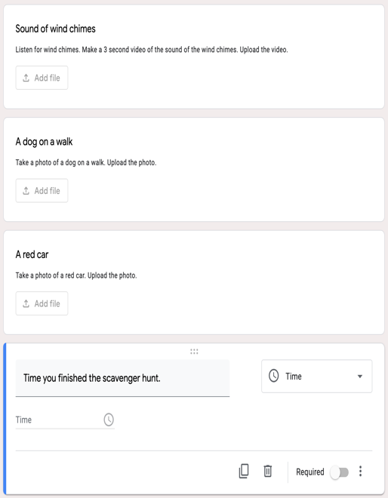
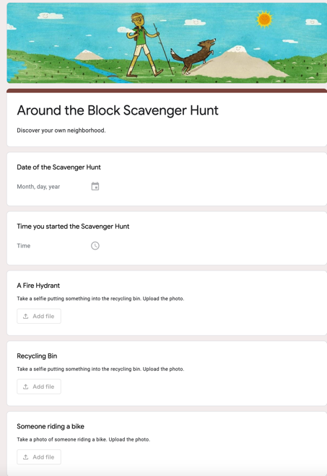

- Around the Block scavenger Hunt with sections
  - https://forms.gle/XvFxb8HC5Jujt5VM7
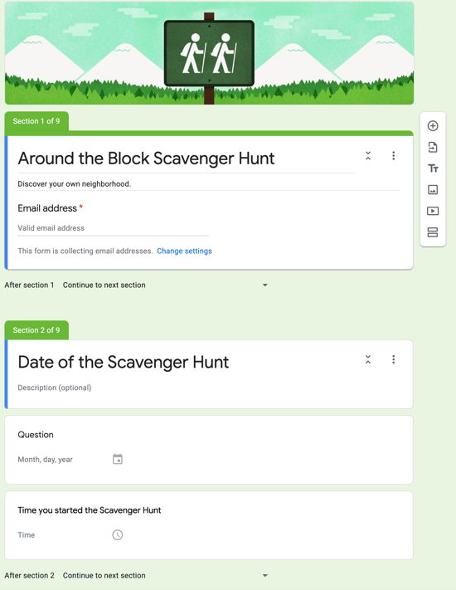
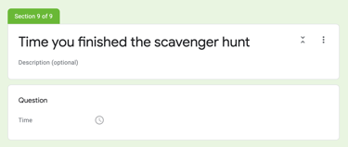
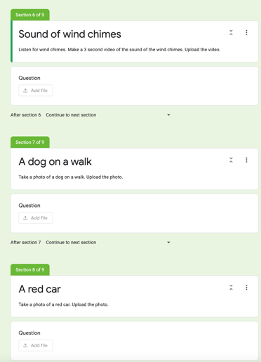
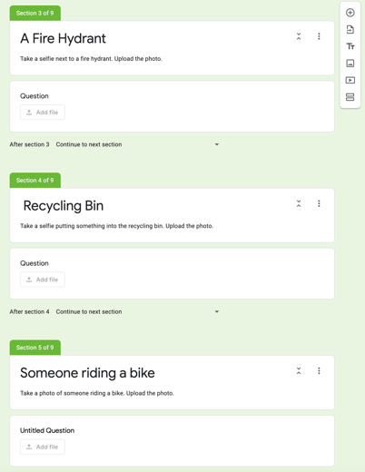
The President’s Challenge
The President’s Challenge is the long-standing program of the President’s Council on Physical Fitness and Sports (PCPFS) dedicated to improving the physical activity and fitness of All-Americans. What started as a simple physical fitness test for youth in the 1960s has evolved into a program that includes:

- Physical Fitness Test
    - A five item fitness test designed to measure the overall fitness of youth ages 6-17. Helping our youth get Stronger Together.

- Health Fitness Test
    - A five item test that recognizes youth for achieving a “healthy level of fitness.”
    - Body Mass Index (BMI) is used along with other fitness testing items.

- Presidential Active Lifestyle Award (PALA)
    - An activity-based program where participants of all ages keep track of their physical activities for a period of six weeks. Great for those just getting started.

Activities:
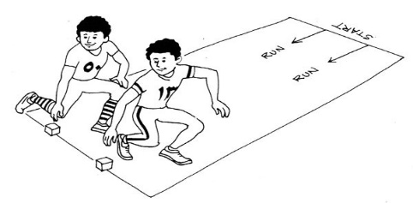
- Curl-ups or Partial Curl-ups
- Shuttle Run
- Endurance Run/Walk
- Pull-ups, Flex-Arm Hand, or Right Angle Push-ups
- V-Sit & Reach

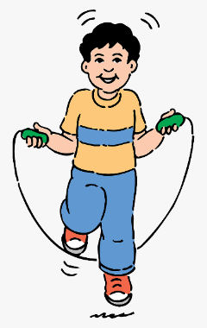
Alternate Activities
- Jump rope
- Pushups
- Sit-ups

Healthy Eating
- The Food Pyramid is designed to make healthy eating easier.
- Healthy eating is about getting the correct amount of nutrients – protein, fat, carbohydrates, vitamins and minerals you need to maintain good health.
- Healthy eating involves:
    - plenty of vegetables, salad and fruit
    - a serving of cereals and breads, potatoes, pasta and rice at every meal - go for wholegrain varieties wherever possible
    - some milk, yoghurt and cheese
    - some meat, poultry, fish, eggs, beans and nuts
    - a very small amount of fats, spreads and oils
    - and a very small amount or no foods and drinks high in fat, sugar and salt
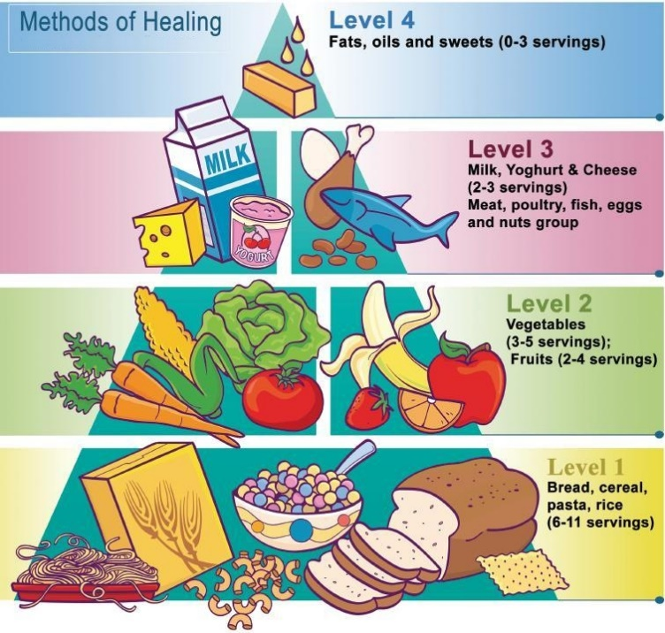
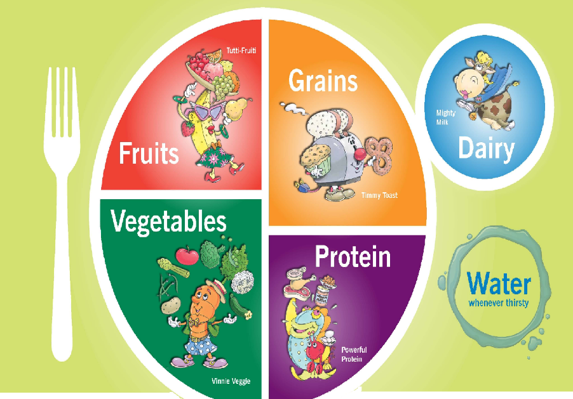

Family Cook Book Activity
- Step 1 – Family member interview
    - Create a series of questions. Decide if the interview will be in English or in the family’s native language.
    - What is your favorite food to prepare/cook?
    - What are the ingredients?
    - What are the steps? How do you make it?
    - How did you learn to prepare/cook this dish?
    - Can we make it now/today/this week?

- Step 2 – Choosing the recipes for the book
    - Choose which, and how many, recipes will be in the book
    - Decide whether you will practice the recipes or just write it up.
    - If you make it, take pictures or draw illustrations. If just writing it up, look for pictures on the internet or create illustrations.

- Step 3 – Choose the recipe format
    - How will the layout of the book be?
    - Digital e-book format, hard copy, handwritten, illustrated, etc.
    - What will each section look like?
    - Will every recipe be illustrated/pictured or just the main ones?

- Step 4 – Creating text
    - Write out ingredients, directions, and procedures.
    - If the recipe will be in English, are accurate translations needed
    - Will the book be bilingual?
    - Will you include family stories, anecdotes, or special instructions?

- Step 5 – Don’t Forget the Math
    - Figure out serving sizes
    - Research nutritional information per serving sizes
    - Identify accurate measurements

- Put it all together
    - Create a binder or book
    - Creating a video of the family cooking together
    - Create a cooking show video

Sample Interview: Titi Nita

Questions | Answer in Spanish | Translation
What is your favorite food to prepare/cook? | Bueno Mija, mi comida favorita para cocinar es la sopa de jamón. | Well, my favorite food to cook is ham soup.
¿Cuál es tu comida favorita para cocinar?
What are the ingredients? | Deja ver. Yo uso:  - Jamón de cocinar  - Sofrito  - Agua  - Papas  - Arroz  - Una taza de salsa de tomate  - un poquito de sal | Let’s see. I use  - Cooking ham (cooked ham on bone)  - Sofrito  - Water  - Potatoes  - Rice  - 1 cup of tomato sauce  - A little bit of salt
¿Cuáles son los ingredientes?

What are the steps? How do you make it? | Primero, pongo la olla con agua a hervir. Entonces pico el jamón en pedazos de diferentes tamaños para variar. Lo pongo en la olla. Cuando el agua empieza a hervir, le añado un cucharón de sofrito, la salsa de tomate, las papas picadas en pedazos pequeños, y media taza de arroz. Le bajo el fuego a mitad altura, y espero hasta que las papas y el arroz se ablanden. Le echo sal si lo necesita. Y ya, tenemos sopa. | First, I put a pot of water to boil. Then I cut up the ham into different sized pieces to vary. I put it in the pot. When the water starts to boil, I add a ladle full of sofrito, the tomato sauce, the potatoes chopped into small pieces, and half a cup of rice. I lower the flame to medium, and I wait until the potatoes and rice are tender. I add a little salt if it needs it. And there, you have soup.
¿Que son los pasos? ¿Como se hace?

How did you learn to prepare/cook this dish? | Mami me enseñó a cocinarlo. Ella a veces le echaba el hueso del jamón para mejor sabor. | Mommy taught me how to cook. She used to put the ham bone in to give it more flavor.
¿Como aprendiste hacer esta comida?
Can we make it now/today/this week? | Bueno, ahora no, porque tengo que hacer sofrito primero. Pero, si me ayudas, podemos hacerlo esta tarde. | Well, not now because I have to make sofrito. But, if you help me with it we can some this evening.
¿Podemos hacerlo ahora/hoy/esta semana?

Sample Recipe Cards

Sample Recipe Page

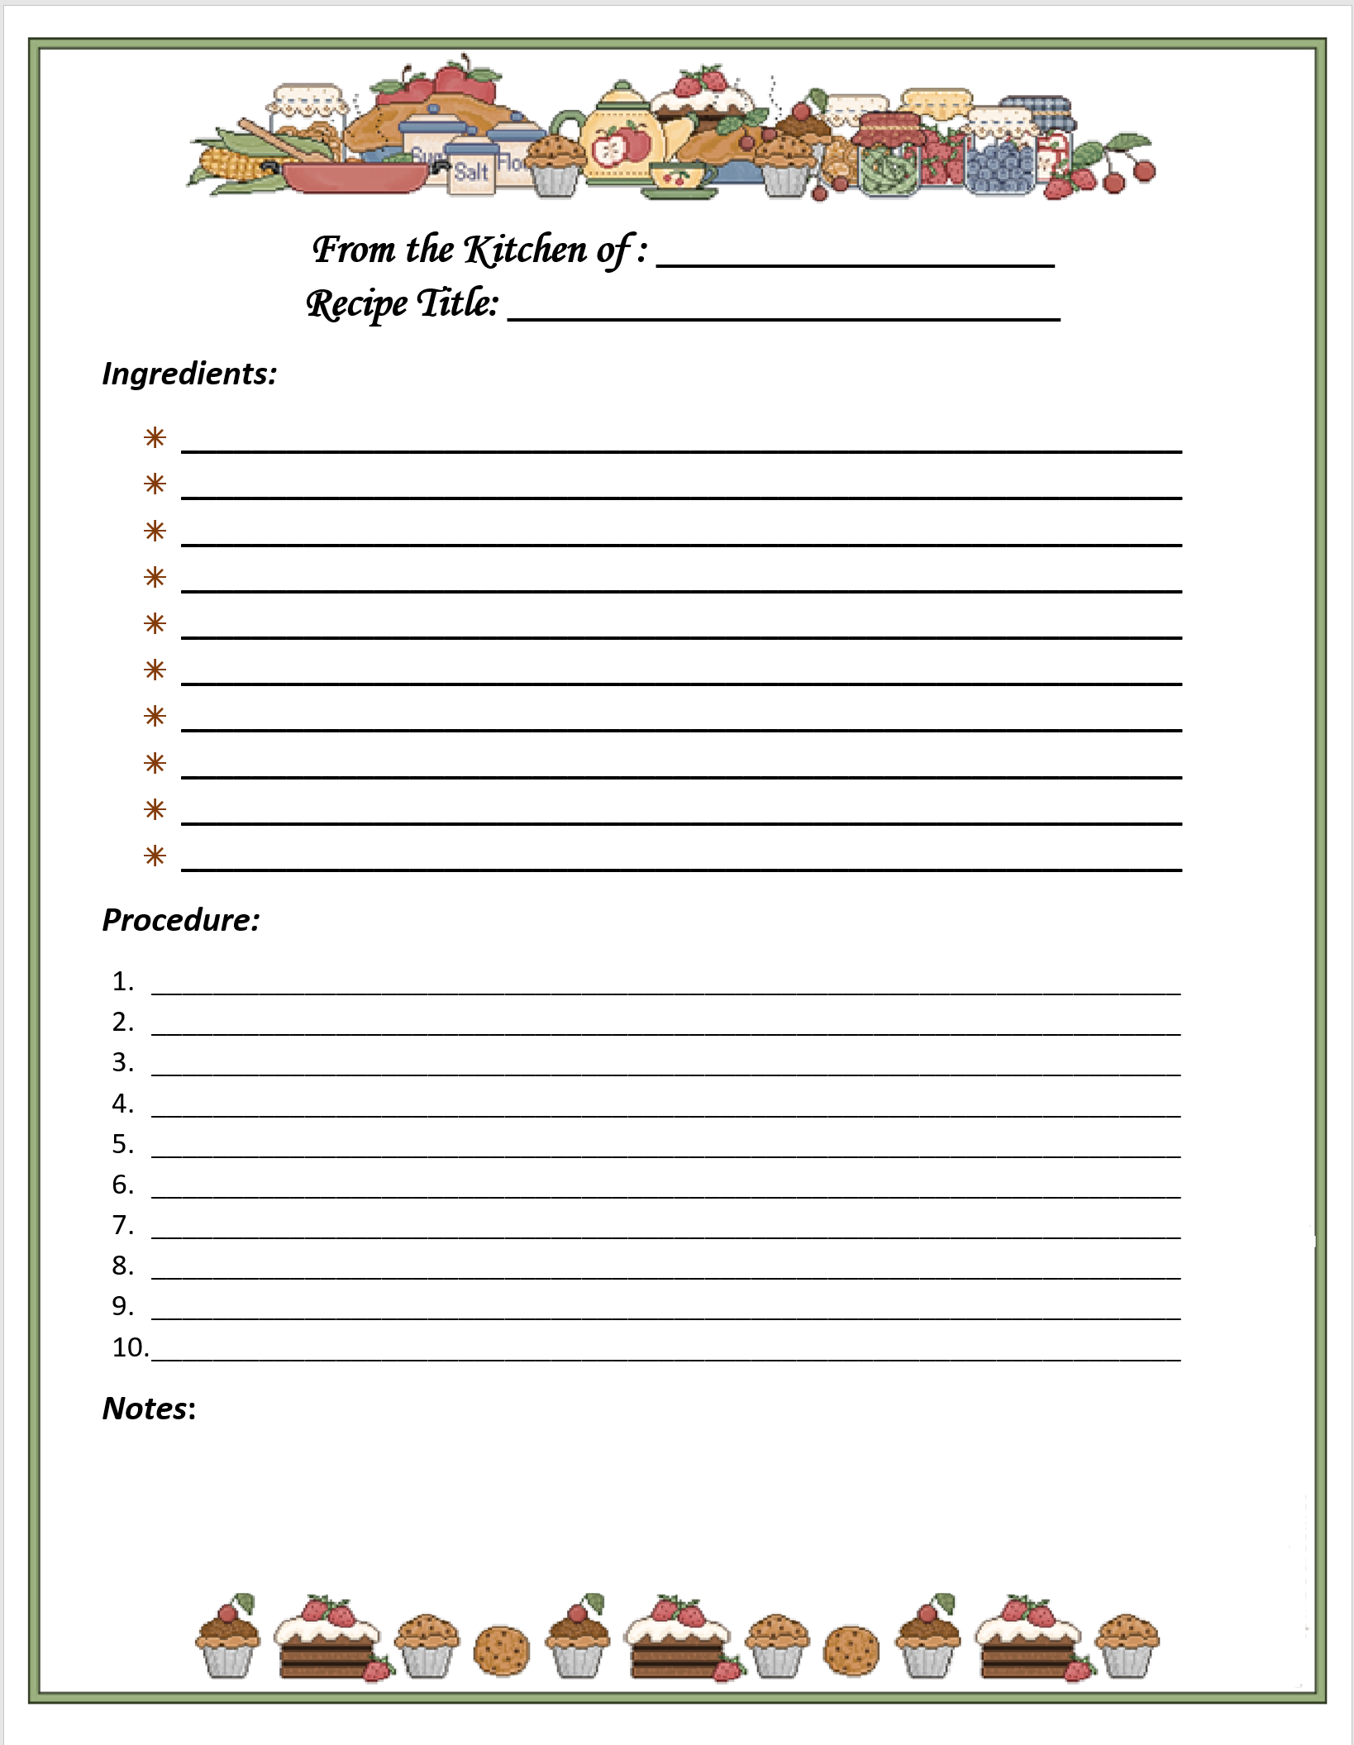

Sample Recipe
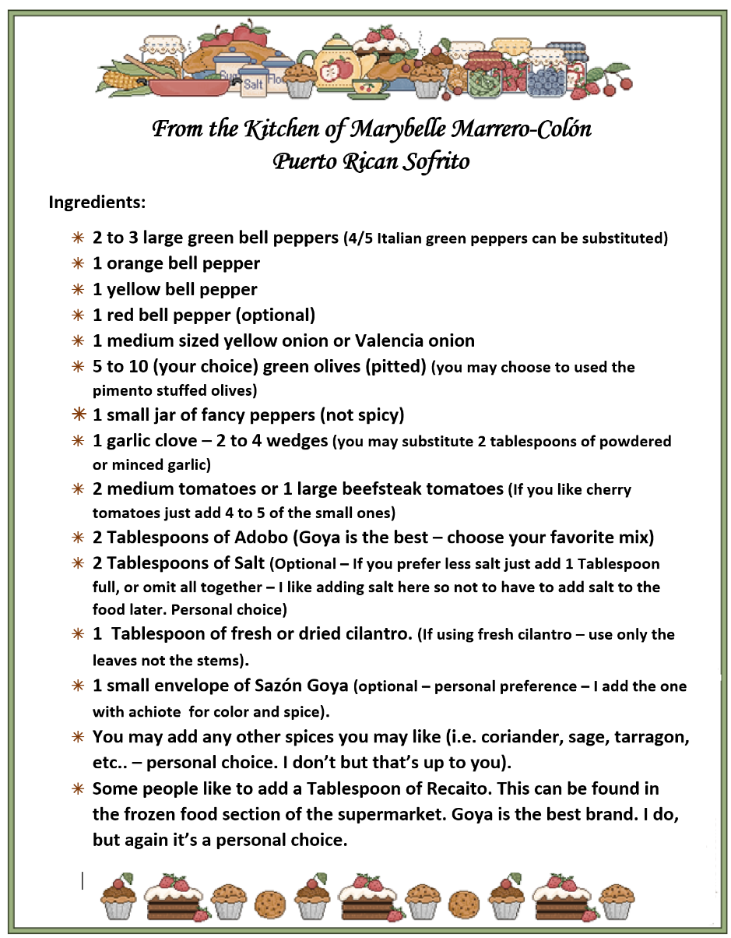
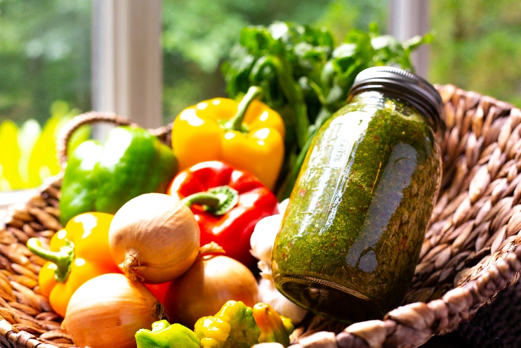
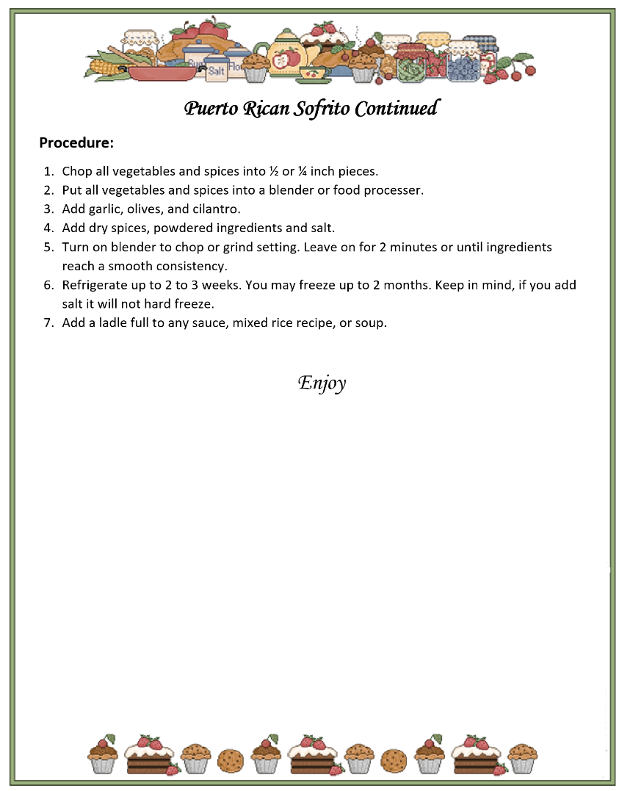

Marrero Family Recipe

Neighborhood Alphabet

Sample Book Club Sentence Frames
- Characters
    - The character that is most like me is…
    - One character that did something I did not like is…
    - If the main character visited our home/neighborhood…
    - If the main character joined our Zoom call…
    - Some ways the character is/is not like me are…
    - Some advice I would like to give a character would be…
    - The character I would choose for a friend is…

- Setting
    - A setting that reminded me of my home is…
    - A setting in the story were I would like to live/vacation is…
    - If we changed the setting to our home/school/neighborhood…
    - If this story was made into a TV show/film, some locations I would use to film it would be…

- Plot
    - My favorite part of the story is…
    - A part of the plot that I found unbelievable is…
    - A part of the plot that I would have changed is…
    - If the story started with the ending…
    - If I were to write another story about these same characters…
    - If this story happened during the global pandemic…
    - If this story happened further in the past…
    - If this story happened far in the future…

Writing Activities Sentence Frames
Writing Task | Sentence Frames/Word Banks
Write a letter to a neighbor | - Dear _______  - I just wanted to send you a message to say…  - My family…  - I have lived here for…  - An activity I like to do is…  - I hope you…  - If you ever need anything…
Write a letter to a first responder/essential worker | - Thank you for…  - We appreciate your…  - Our community is so lucky…  - I hope you…
Draw and label a neighborhood map | - My house  - Park  - Playground  - The _________ Family  - Mr. and Mrs. _________’s House  - Restaurant  - ____Street  - Mailbox
Create and label a Brochure labels | - Welcome to…  - Visit ______  - Enjoy ______  - Activities to enjoy include…  - The weather is always…  - Dining options include…  - Things to see…  - Learn about…
Create a sign thanking essential workers | - Thank you for…!  - We appreciate you!  - We are thankful for your hard work!  - We are grateful you are keeping us safe!
Letter to the editor/congressperson/school board member | - Dear Mr./Ms./Dr./Senator/Representative  - In my opinion…  - Based on the evidence I have read…  - I read an article that stated…  - While some argue…, I

Charades Games
- Help your friend/family member guess by describing the featured word-without saying the word.
- Play with any size group of friends/family.
- Give your friends/family member clues to help them guess the word on their forehead.

Wheel Decide
- Dynamic digital wheels- wheeldecide.com
  - What Emotion? Improve and acting game
  - What to cook? Spin meat, starch, vegetable, fruit, nuts, herbs/spices
  - Twister Spinner
  - What to do under quarantine? 16 ideas
  - Who gets the short straw
  - Magic 8-ball
  - Coin flip

VOA Learning English - Learningenglish.voanews.com
- Multimedia source of news and information for millions of English learners worldwide
- Audio programs and captioned videos
- Beginner, Intermediate, and Advanced levels
- English in a Minute
- A Day in Photos
- English @ the Movies
- News Words
- U.S. and World News

Audiobooks/Podcasts
- Unite for Literacy
- Storynory.com
- Tumble Science Podcast for Kids
- Epic!
- Africanstorybook.org

Olympic Ribbon
Reminder: Color the prize ribbon gold if you do 8 activities, silver if you do 6 activities, and bronze if you do 4 activities.

President’s Council on Physical Fitness and Sports (2010). We are all Americans - stronger together: The president’s challenge. Washington D.C. U.S. Department of Health & Human Services; 3-10.
U.S. Department of Agriculture. (2013). Choose My Plate. Washington, D.C.; Retrieved: https://www.choosemyplate.gov/

