Flipgrid Links
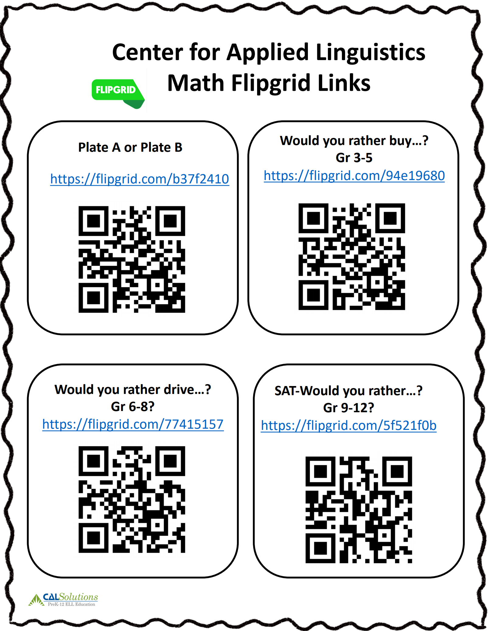
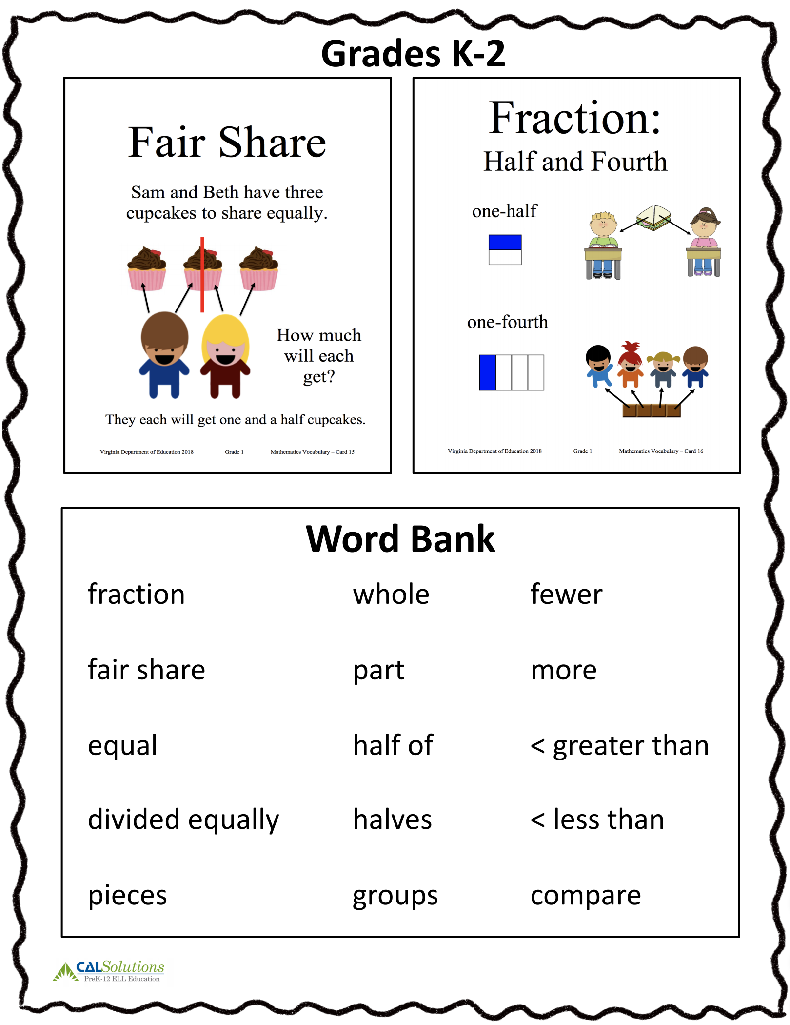
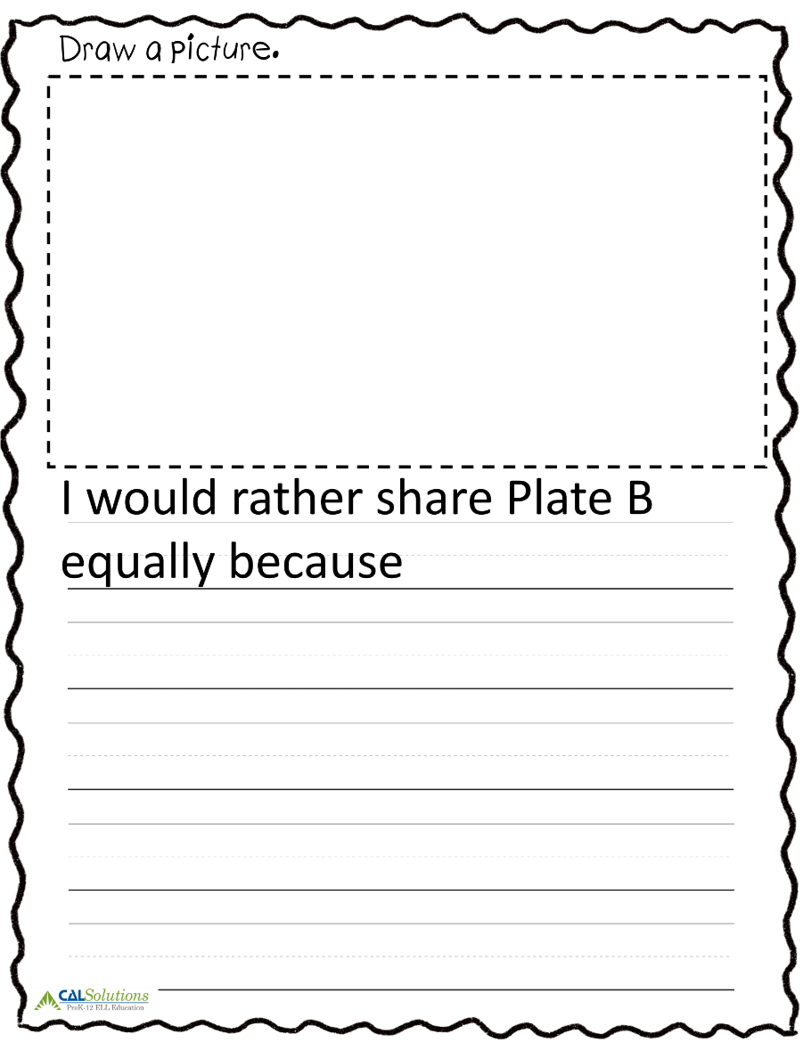
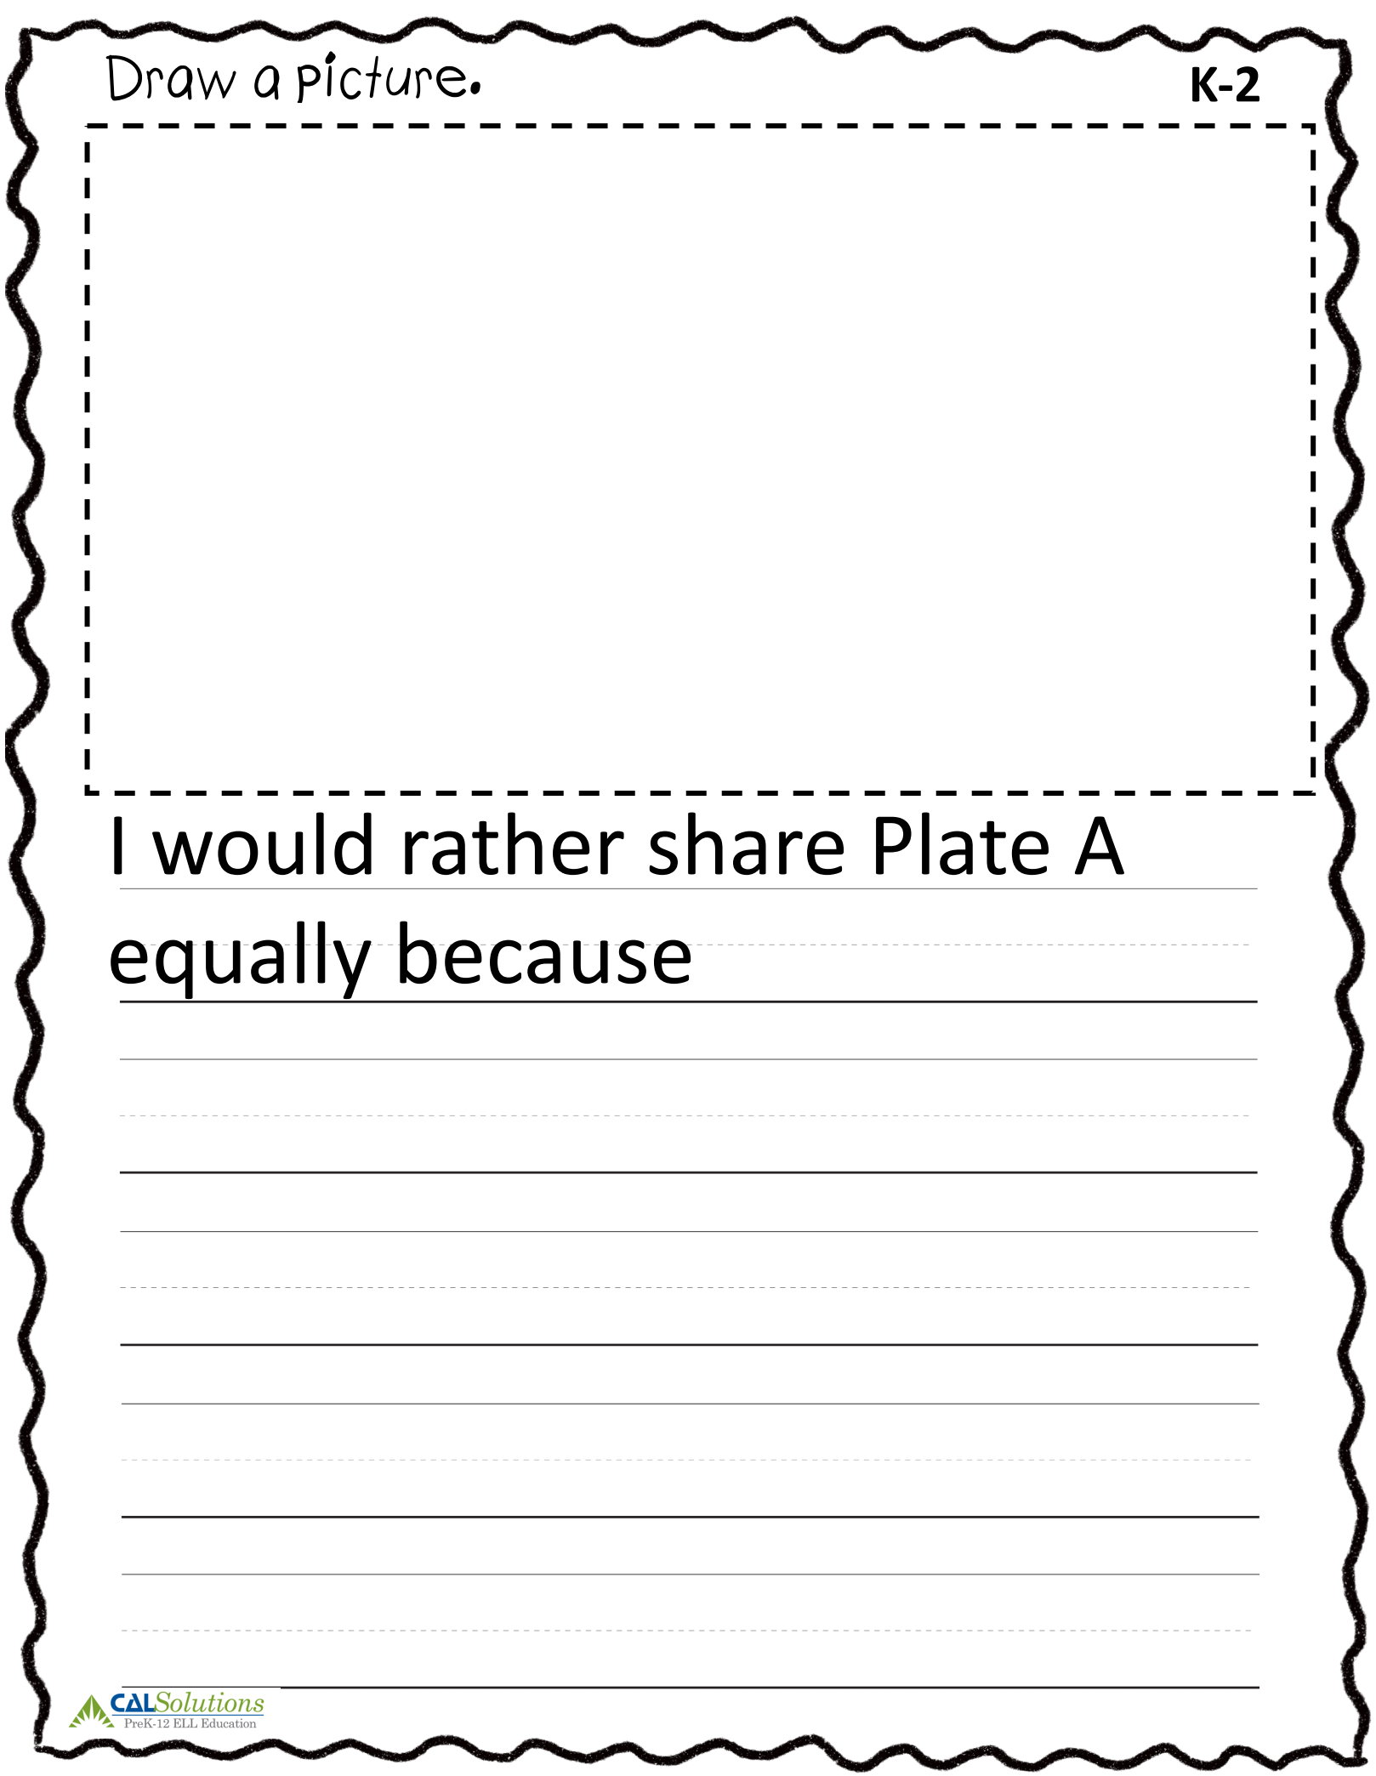

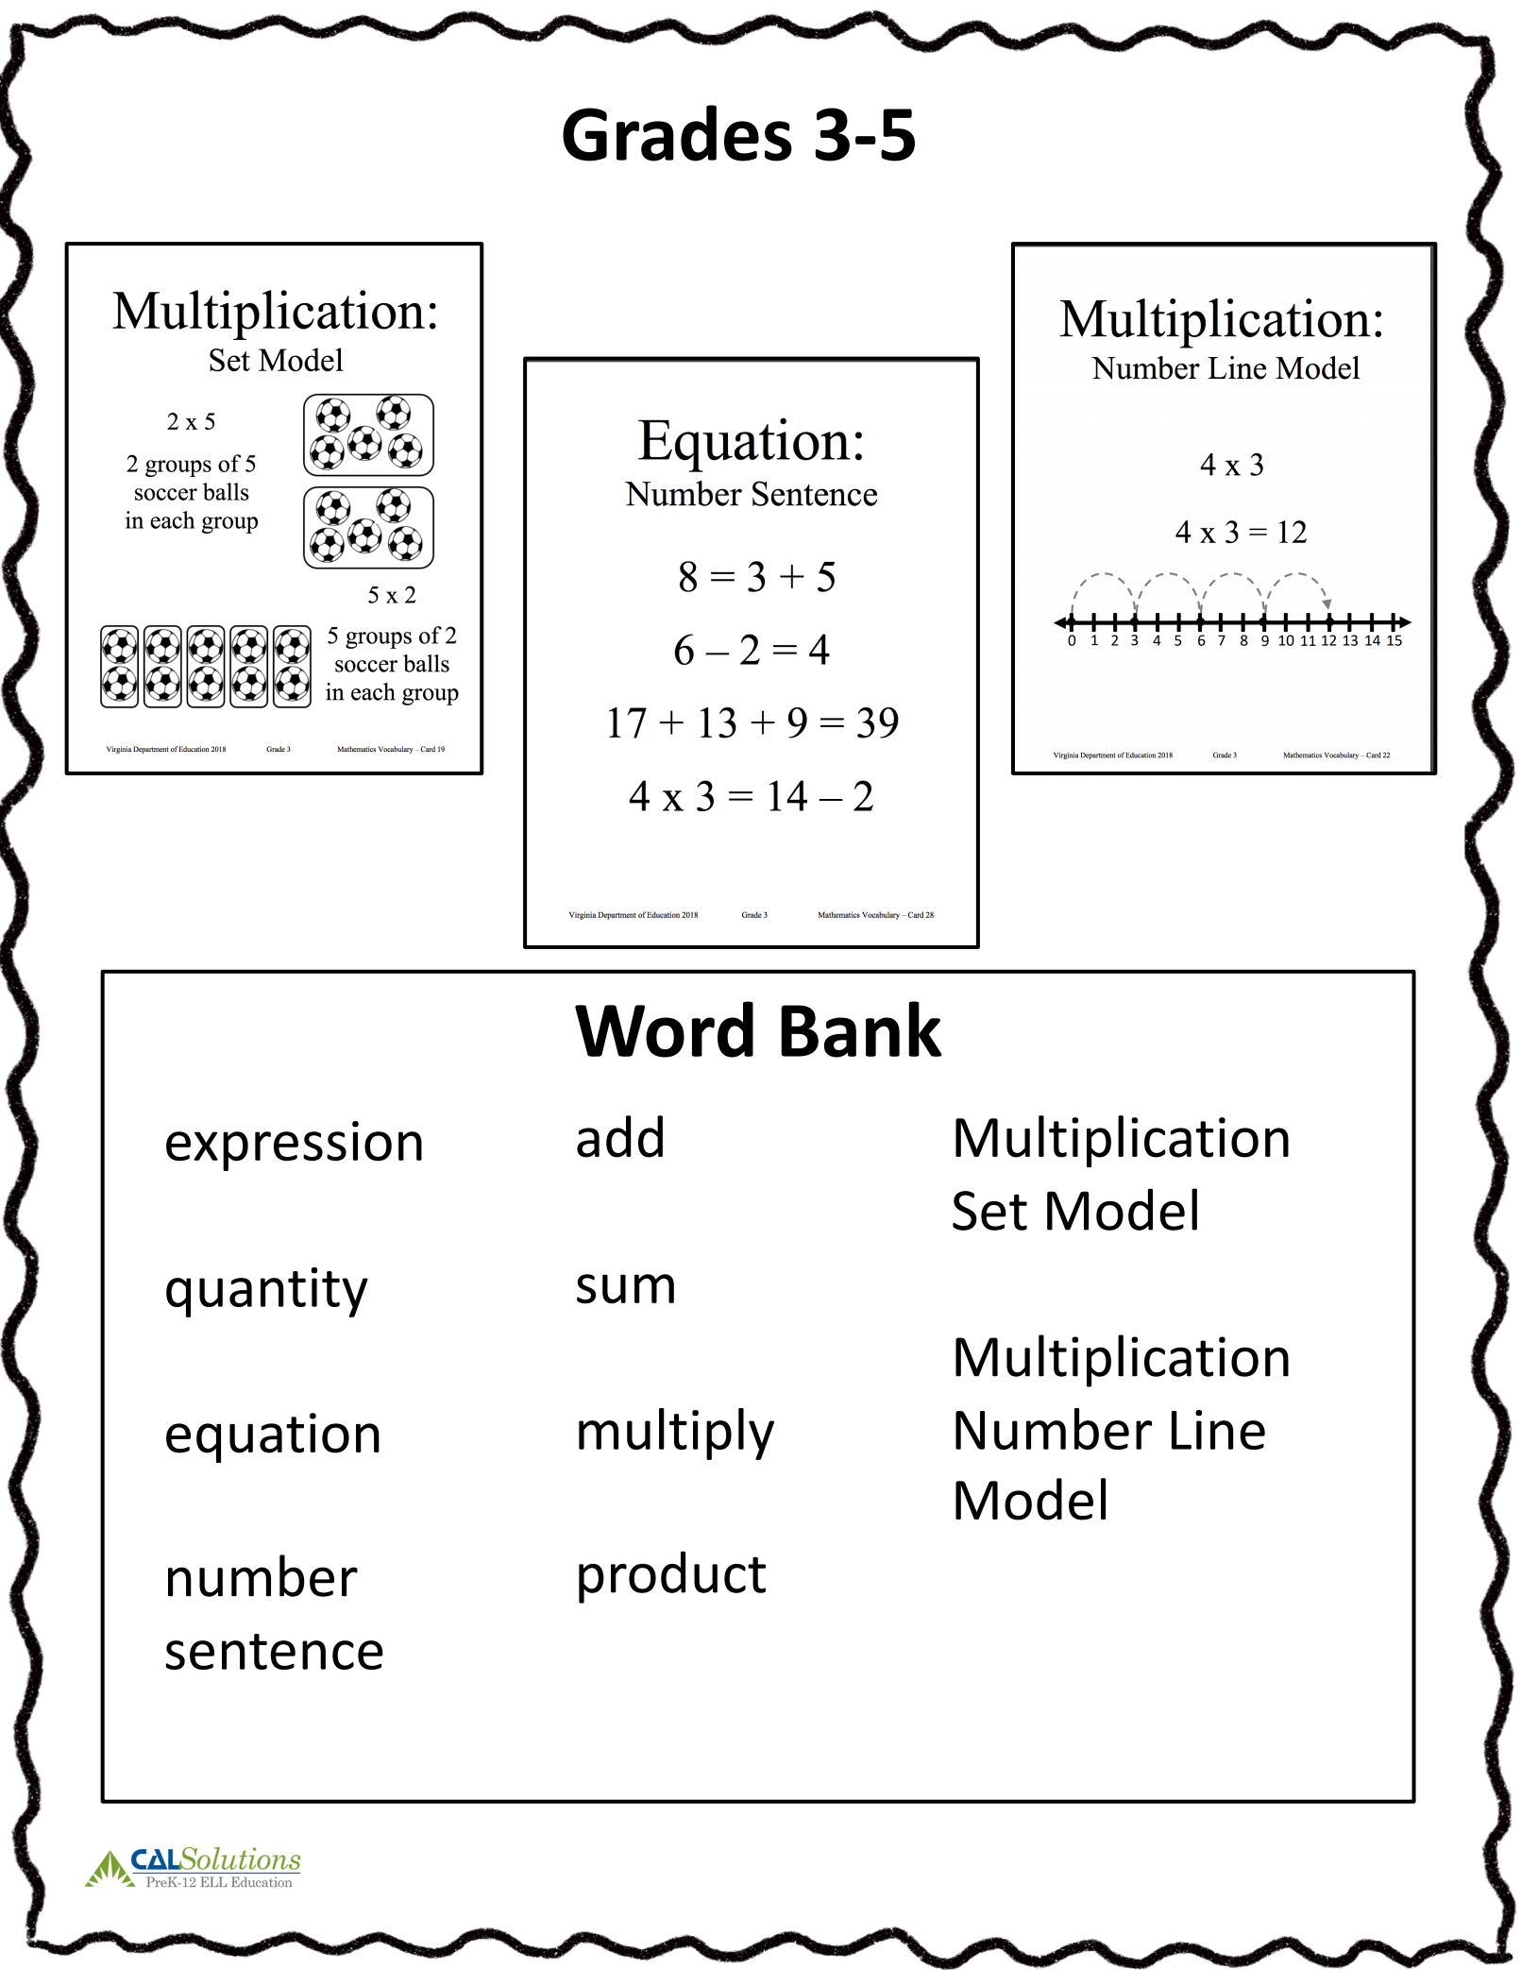
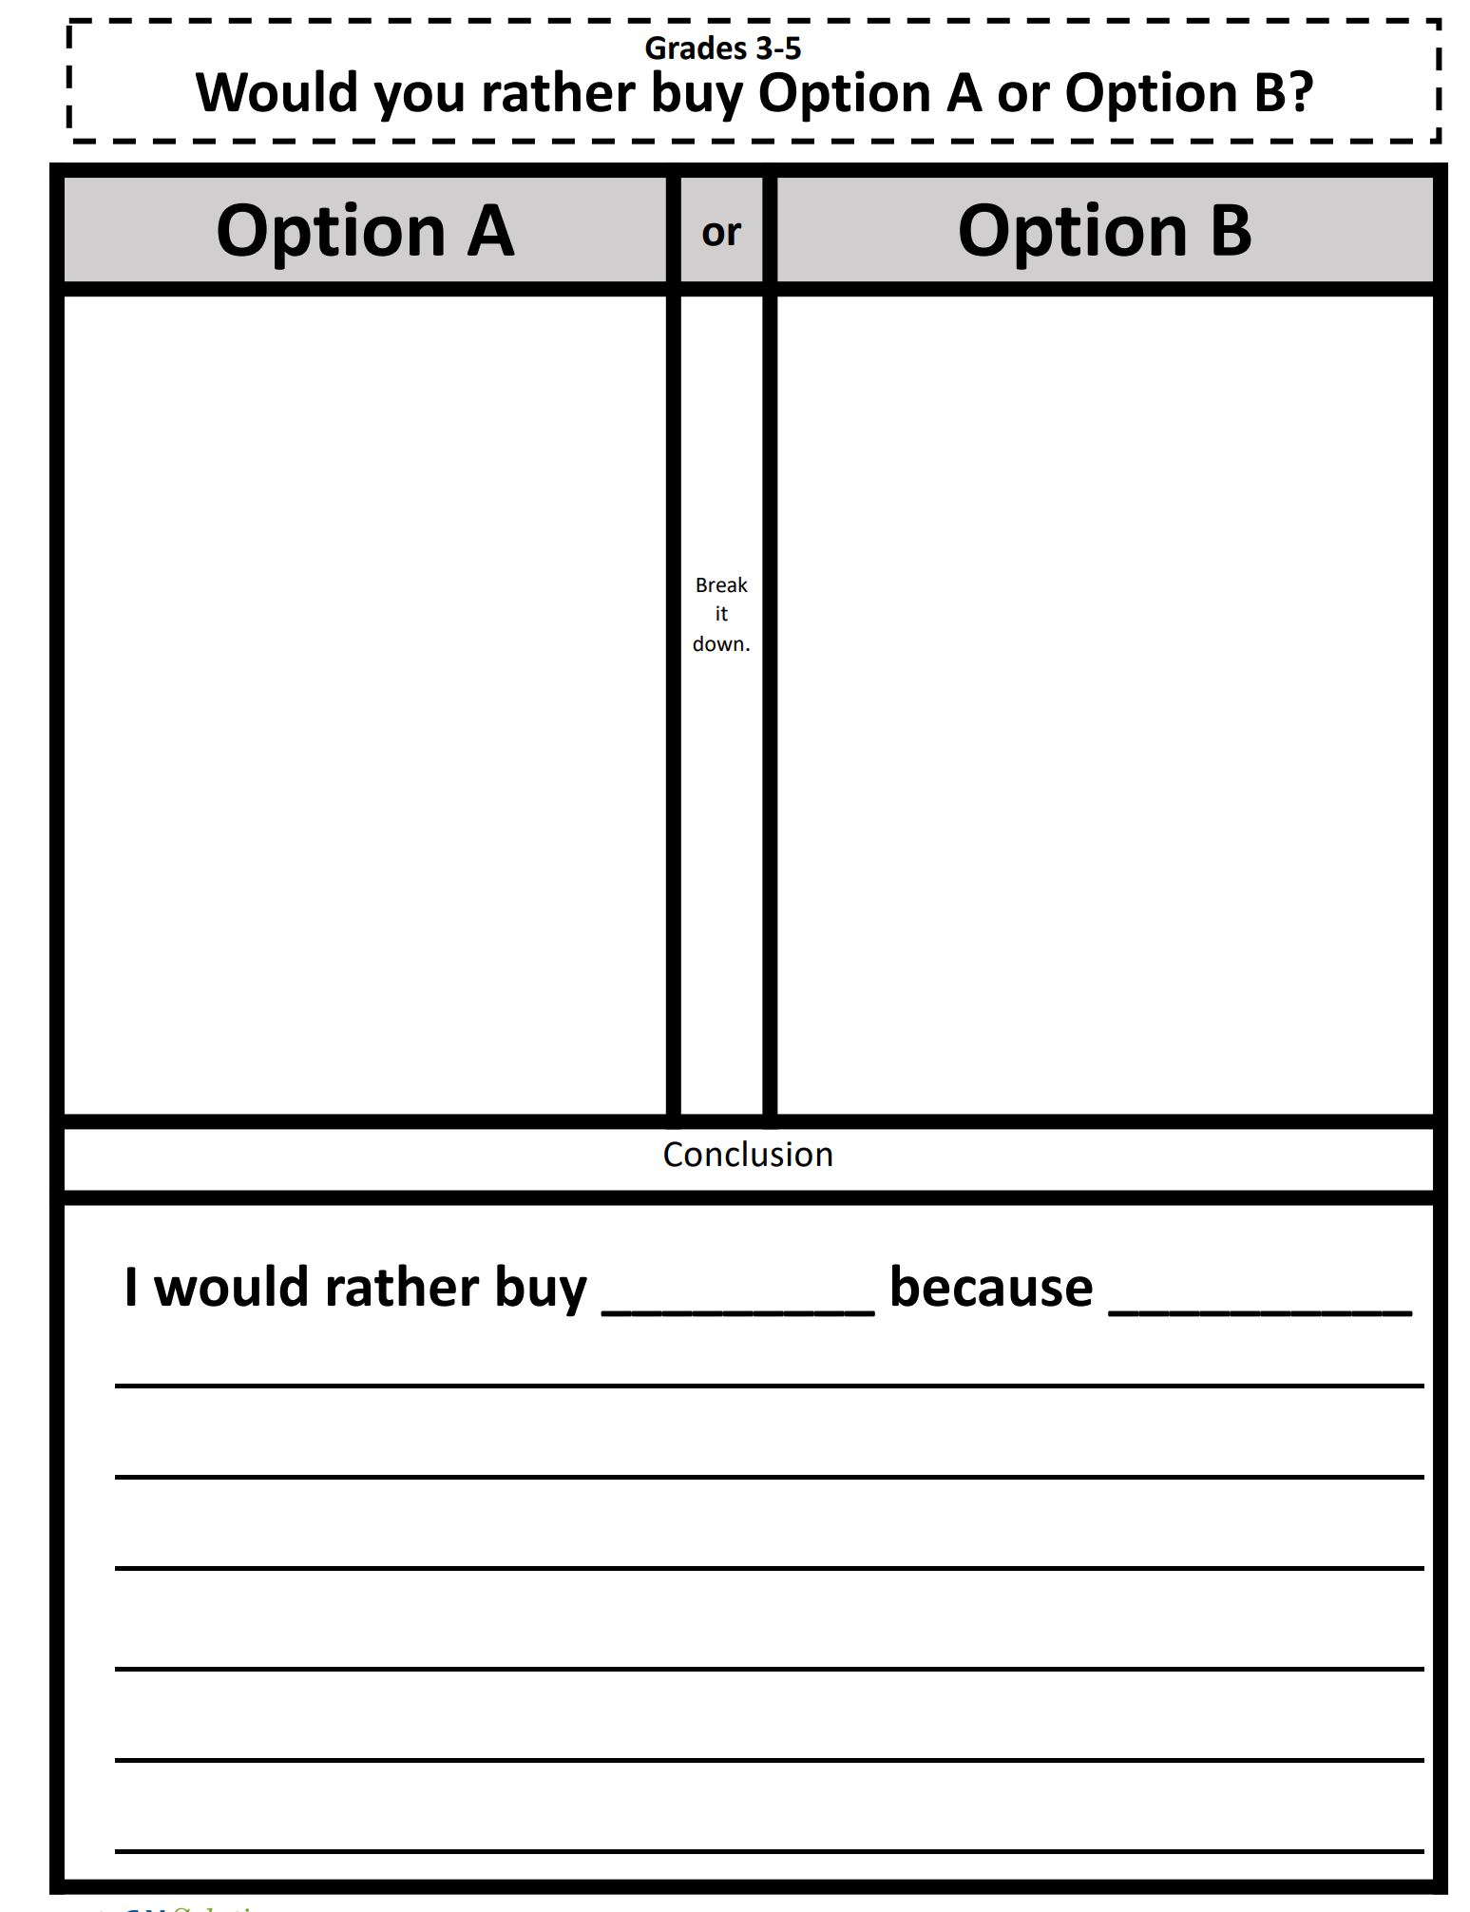
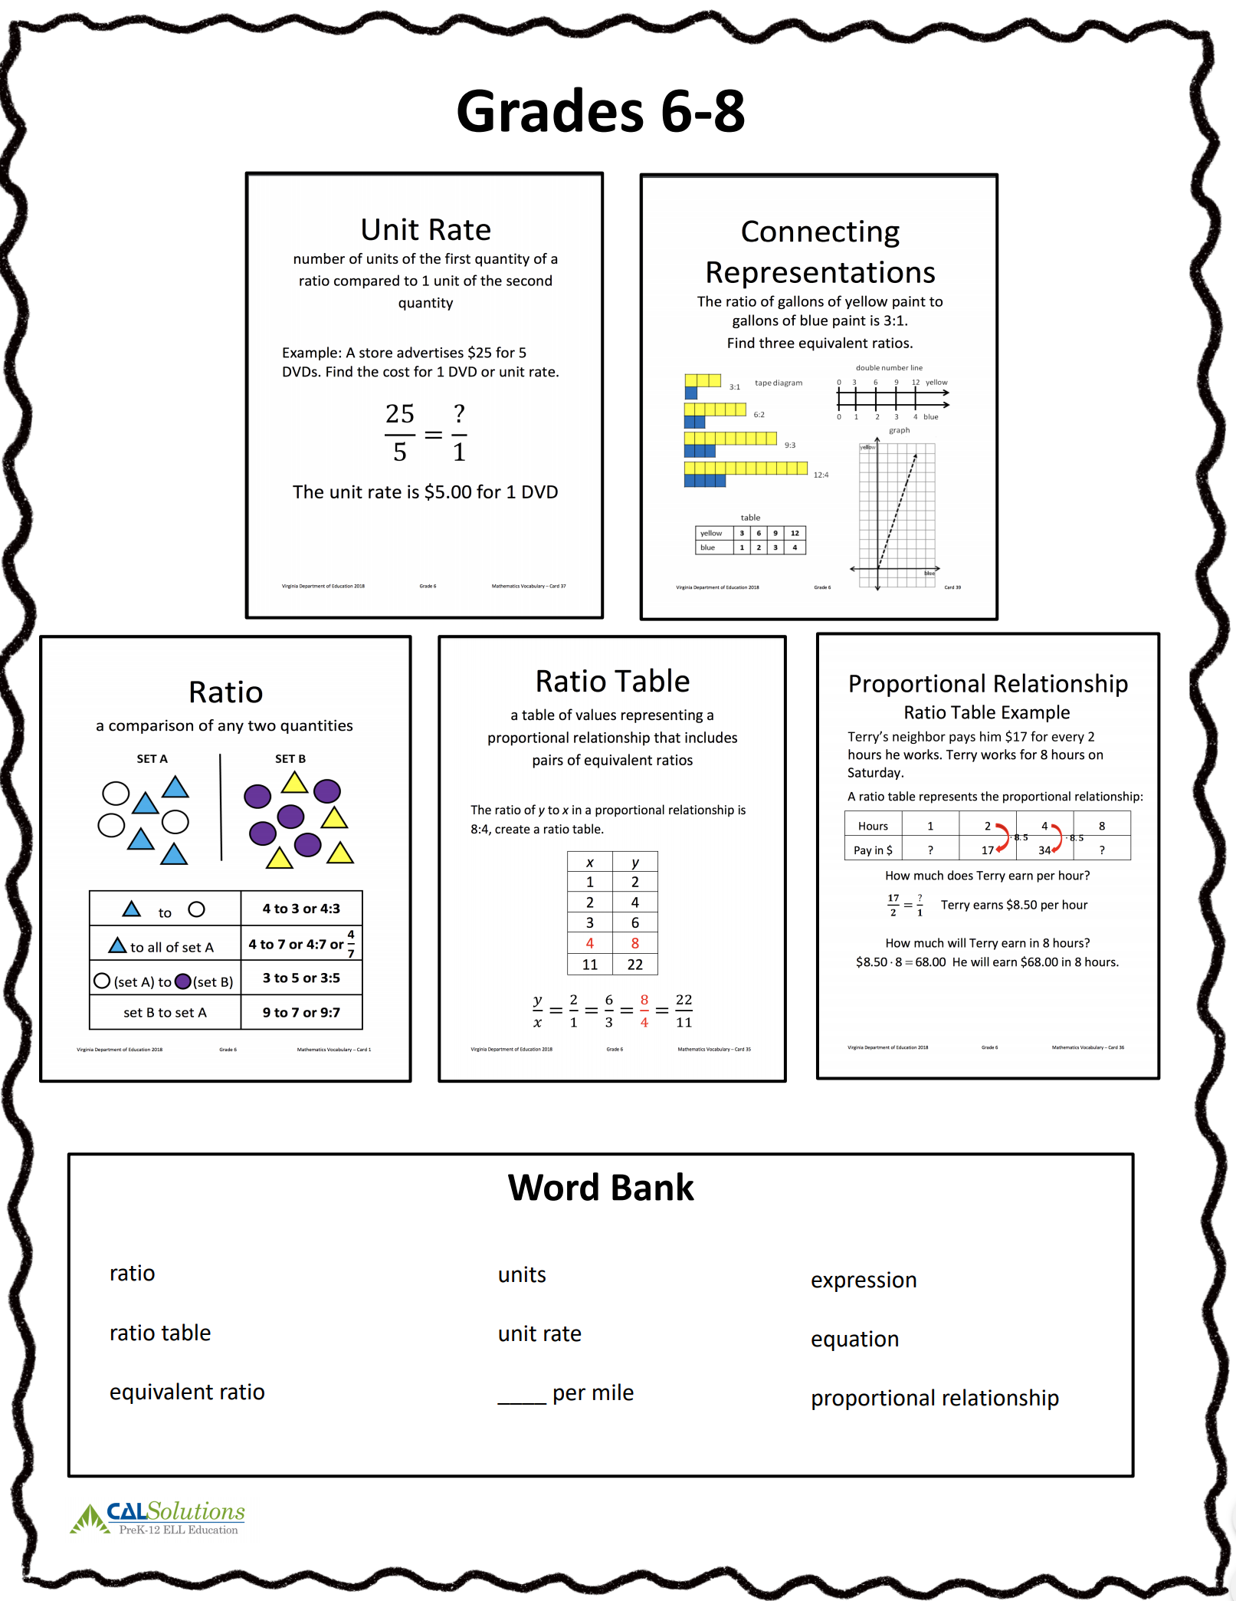
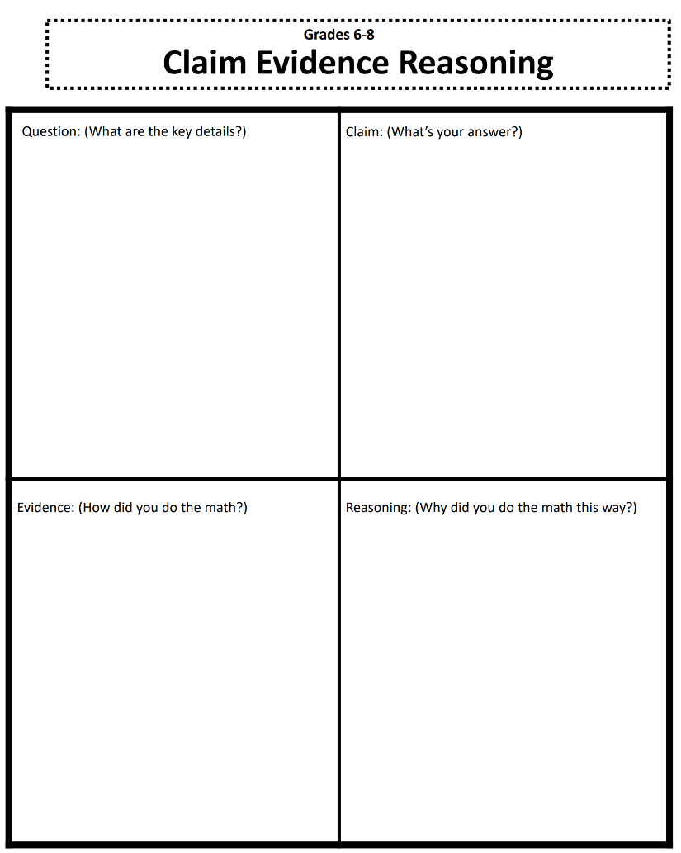
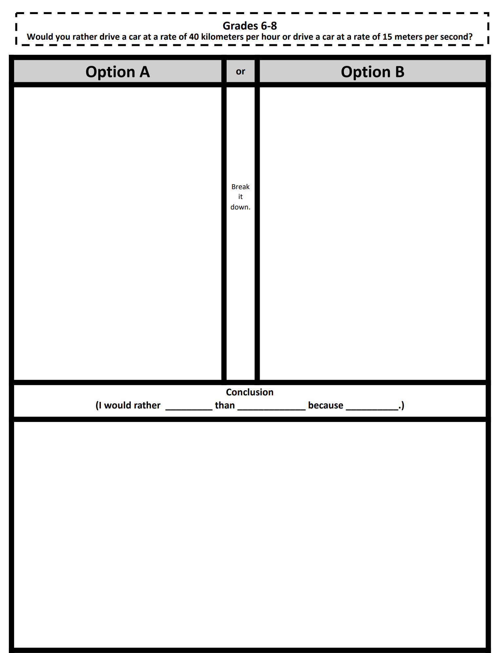

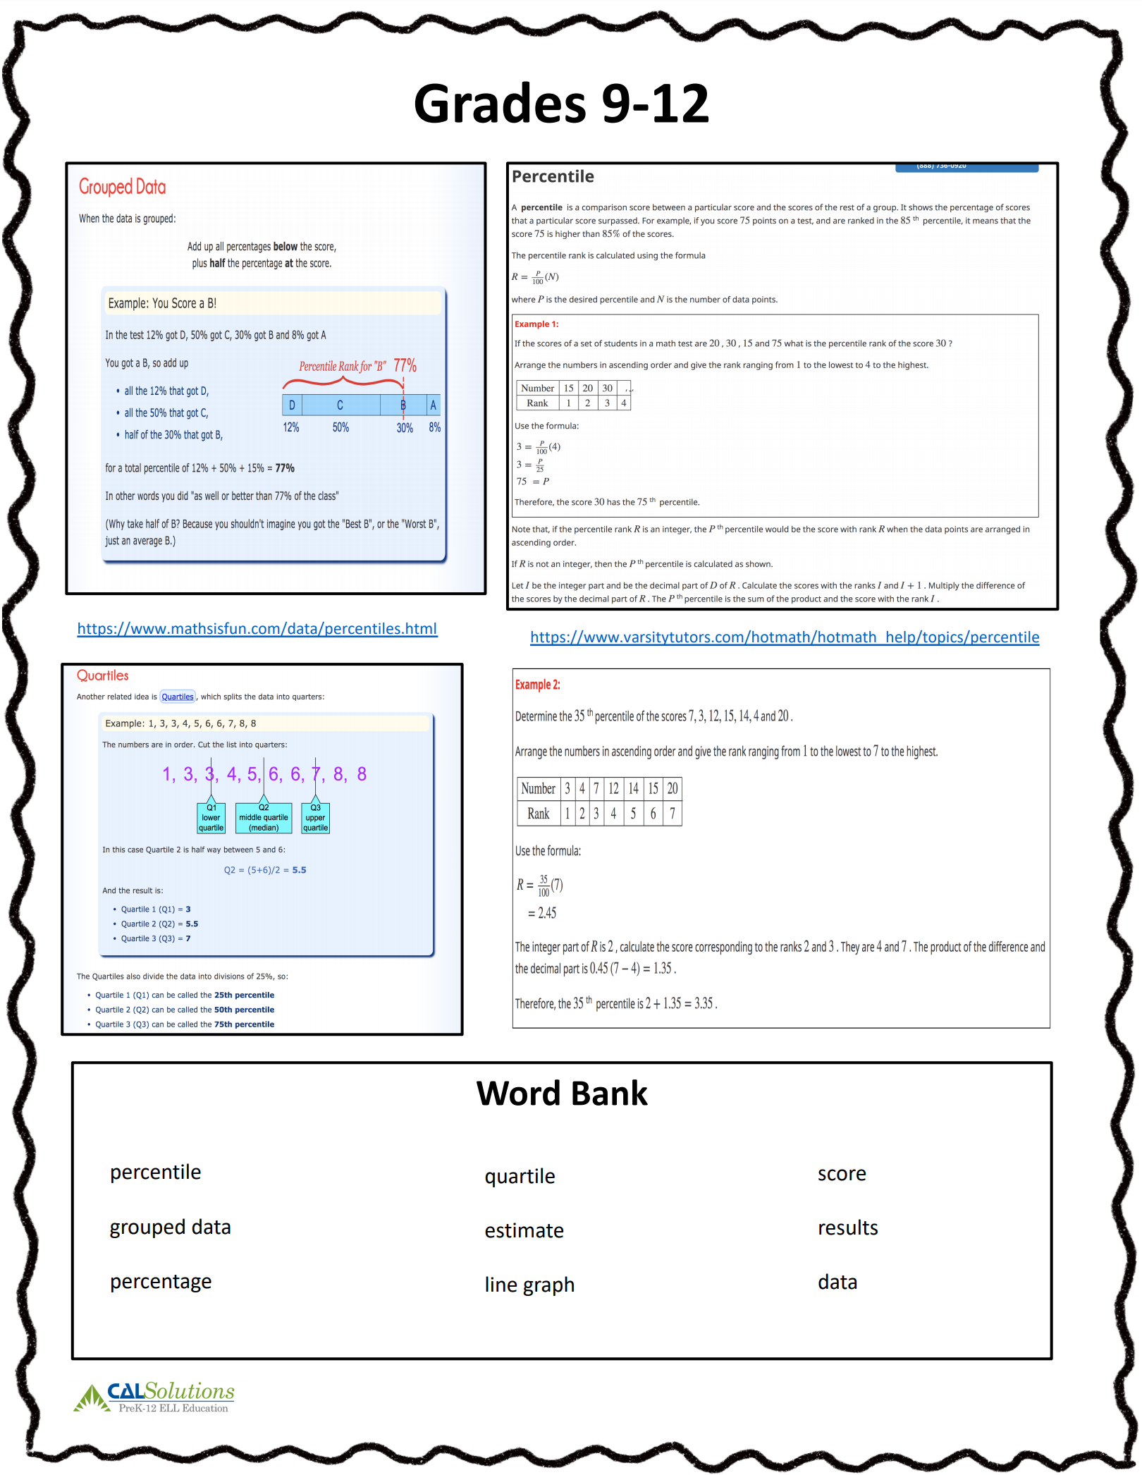
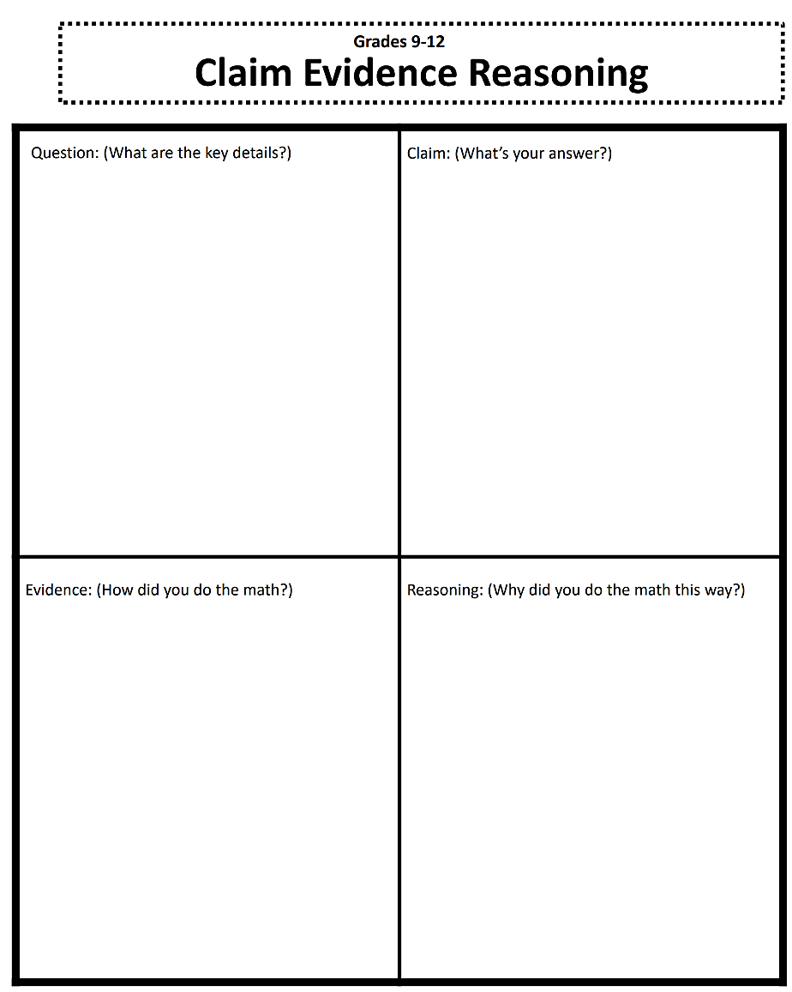
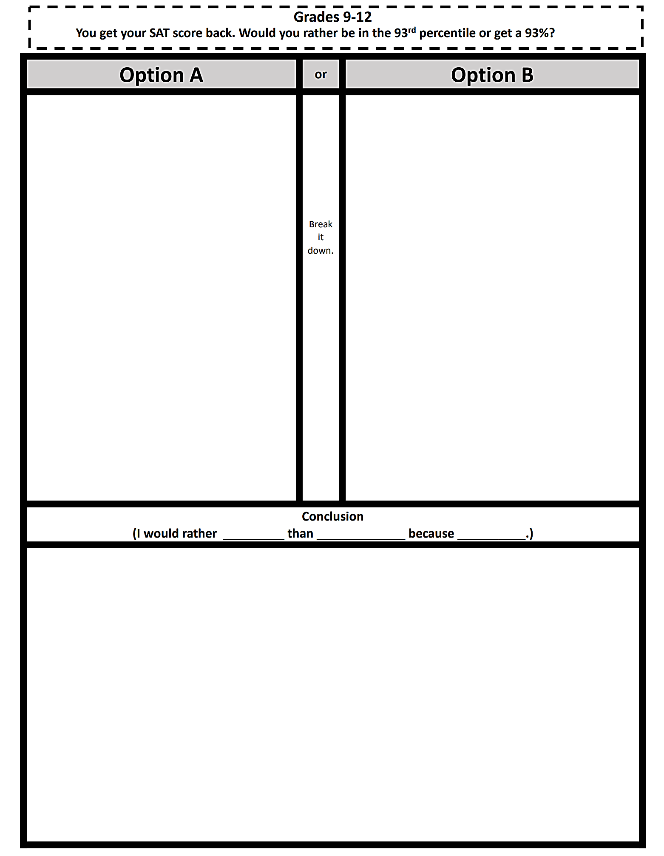

Promoting Math Literacy in the Home

Forget the Question:
- Display a problem scenario, only include the mathematical scenario. Leave out the question. Only after all students have participated and understand the scenario thoroughly do you reveal the question. Or, ask students, “If this story were the beginning of a math problem, what could the math problem be?” Then solve a problem the students came up with.
- Leaving off the question increases participation from struggling students because there’s no right answer and no wrong noticings and wonderings. It keeps speedy students engaged in creative brainstorming rather than closed-ended problem solving. Having a question to solve that students generated increases all students’ understanding of the task and their engagement.
- Ask students, “What do you notice?
- Record students’ thoughts; thank or acknowledge each student equally. Record all student suggestions.
- Ask students, “What are you wondering?”
- Record students’ wonderings.

Adapted from National Council of Teachers of Mathematics, “Problems of the Week”
Example of Forget the Question
- Collaborative Google Slides: https://bit.ly/2yt5zCd

Making Math Comprehensible

Consider some of the following activities and how they could help make Math more comprehensible.
- Visuals or models
- Drama, role-play or readers’ theatre
- Manipulatives
- Demonstrations
- Bingo or other games
- Timeline
- Inside/outside circles
- Round Robin Writing
- Zip-Around/I have, who has?
- What others could you add to the list?

Activities to try at home

- Beat the Clock Toss
- One student becomes the Timekeeper. The timekeeper:
  - Sets the timer, turns the card with number concept (e.g., Counting by 2s up to 30, 6 times tables up to 6 x 12, names of geometric shapes (2D and 3 D), and chooses the first participant by tossing the ball.
- That student thinks of an association with the concept and then tosses the ball to another student who thinks of another.
- Repeat until the ball has gone around the group 2x or until all answers are given.
- Stop the timer and as a group summarize what was covered during the game.
- The timekeeper writes out the summary for the group.
- The last student holding the ball becomes the new timekeeper for the next go-around.

- Multiplication Dominos
- Dominos are placed face down on the table.
- Students take and turn two dominos over.
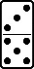
- Students then:
  - Add the pips on each domino 8 x 6 = 48
  - Multiply the pips
- The student with the greatest/lowest (students decide) number wins.
- Variation:
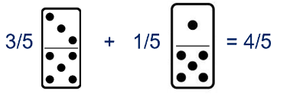
  - Each domino is taken as a fraction and is added, subtracted, multiplied or divided. For example:

  - For younger children, the students can add or subtract instead of multiplying.

- Math Battleship
- Students are given a math worksheet (i.e. simple algebraic equations) to solve. They compare their answers prior to playing the game.
- Each equation is then given coordinates to a secret location on their game board (i.e. C3, A5, D1, etc.).
- Students are given a game board with 2 sections. In section 1 they will fill in their secret locations, section 2 is where they record their hits and misses.
- Students take turns guessing where their opponents answers are. If they are write, it’s a “Hit”. If they are wrong, it’s a “Miss”.
- The first student to “Hit” all of their opponents answers, wins.

Name: _______________________________ Student A/B

Battleship
Directions: Solve each equation below. Give each equation a location on your battleship board. Draw a boat on your board and place your answer inside the boat.

39 = 3r | -22 = 7(9a – 2)
-7 = 5 + z | -2 + 4(1-9x) = 21
21 + 5k = -3 | -11 = 5 = d
8r – 27 = -26 | 3x + 7 = 25
15x + 6 = 36 | 6c – 6 = 48

Math Battleship

Player ________

Directions: Mark 10 spaces on your answer board with a boat. Place your answers from the equation sheets in those spaces. Leave all other spaces empty. On your equation board, write down your guesses as either “HIT” or an X if you Miss.
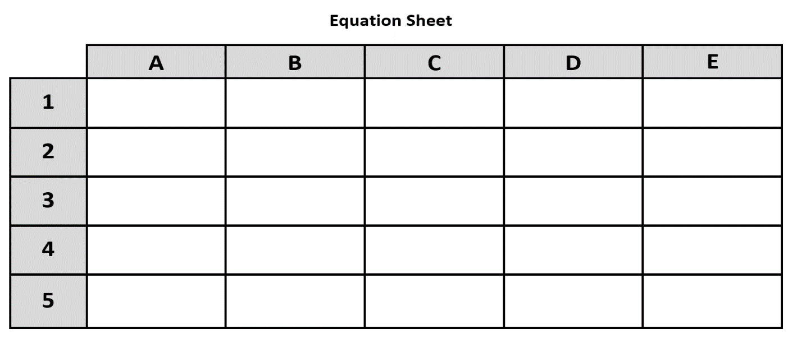
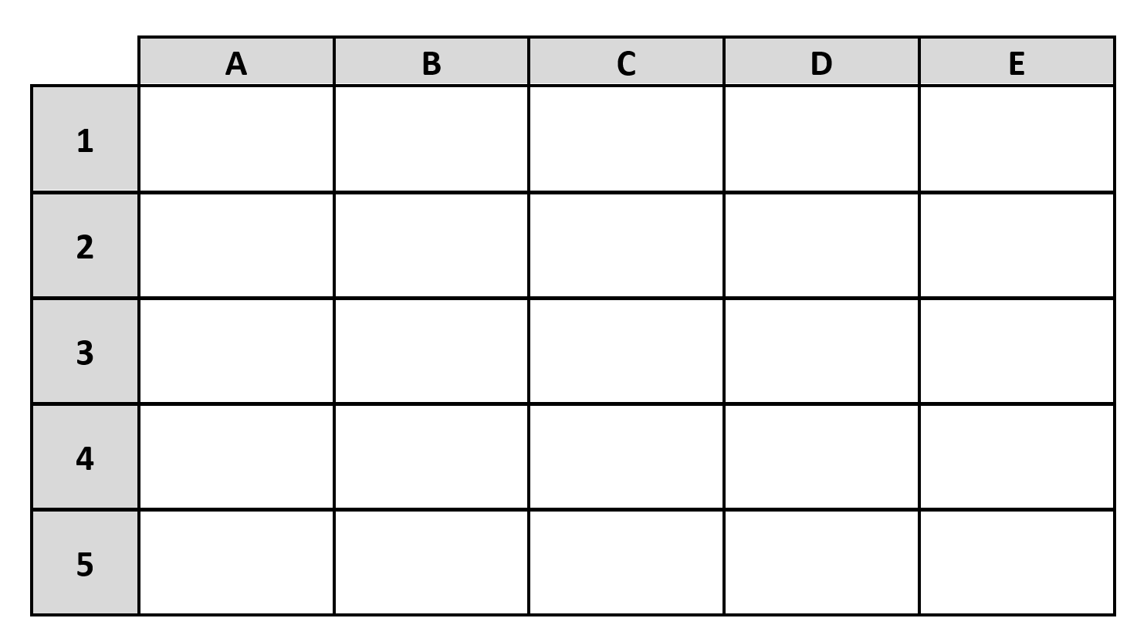
Answer Board

Sample:

Solve the math equations either on your own or as partners.
Give each problem a coordinate.
A1  48 = 3x + 3  -3 - 3  45 = 3x = 15 = x  3 3 | D5  144 = 12x + 6(4) 120 = 12x  144 = 12x + 24 12 12  -24 - 24  120 = 12x 10 = x

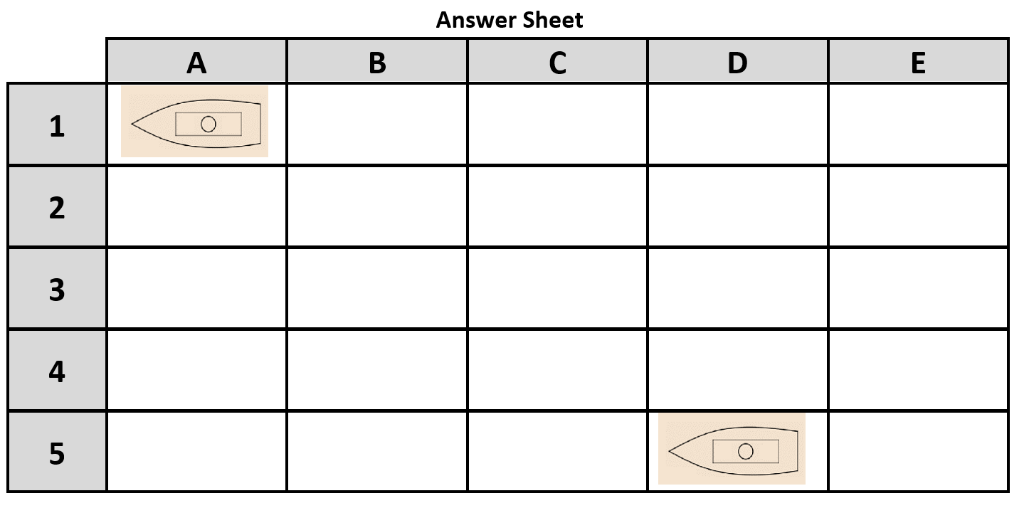
Place your boats in position here using your coordinates
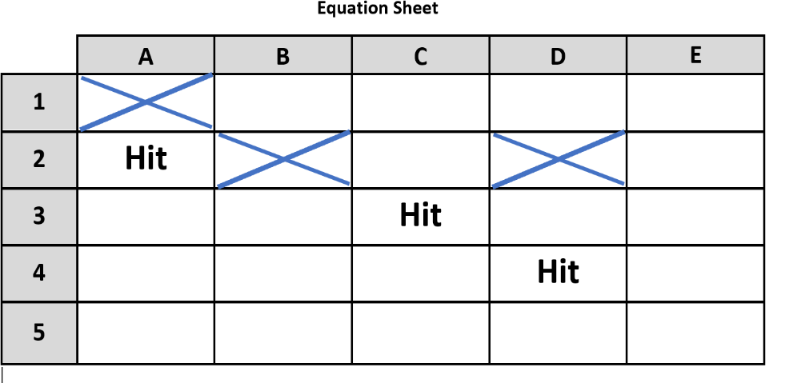

Call out coordinates, and place your guesses for your opponent’s boats here. If you guess right, mark it as a “Hit” if you are wrong, mark it with an X.
- Race to 27
- Deal out all of the playing cards to the players. Players put their pile of cards in front of themselves face down
- 1st player turns over their top card and places it in the center.
- The next player turns over their card placing it on top of the first card. This player adds the value of the two cards.
- The next player does the same adding the value of their card to the previous total.
- Play continues until the total reaches 27 or over. The player who puts down the card that takes the total to 27 takes all of the cards in this pile and shuffles them into their pile.
- Play continues for a set time or until one player has no
cards left. The winner is the person with the most cards.
- For a more advanced version you can play Race to 50 or
Race to 100

- Mean, Median, Mode, Range Game
- In this activity students use plastic cups, blocks, or other object that can be easily stacked.
- They are given a specific amount of time (i.e. 1 minute, 30 seconds, etc.) to build a tower.
- They then record the number of cups, blocks, or other objects used.
- They do rounds where they do the building various times (trials) and copy down the data.
- From the round data, they figure out the mean, median, mode, and range.
- Let’s see what this looks like…

Round 1 – 1 Min |  | Round 2 – 30 Sec
Trial | # of Cups | Trial | # of Cups
1 |  | 1
2 |  | 2
3 |  | 3
4 |  | 4
Totals |  | Totals

Trials | Mean | Median | Mode | Range
Round 1
Round 2

- Backward Building (Story Problems)
- Purpose: to help learners link language to operations in story problems
- Start with a full visual equation:
- Begin to build in language first by naming the equation orally: eight times three minus nine equals fifteen
- Add objects: Three bowls with eight marbles in each bowl, take away nine marbles
- Add people: I have three bowls with eight marbles in each bowl. I take away nine marbles. How many marbles do I have left?
- Change the people and the containers: Maria has three boxes of chocolates. Each box contains eight chocolates. She gives nine chocolates to her friends. How many chocolates does Maria have left?
- See how many different ways learners can create stories for the equations.
- Highlight the words that show operations.
- Practicing backwards helps learners think flexibly when moving from a story problem to an equation
- Demonstrates the variety of language that can be used to show the same equation
- Can be differentiated for learners at different grade levels
- Easily adaptable to a flip grid activity
- Can be done at home with everyday objects

Neighborhood Bear Hunt Math Activities
Directions: Choose one or more of the methods or ways to count and analyze the data from your Bear Hunt below. You can try each method on separate days and compare the data.
Tally marks—use tally marks (where is a group of five) to count how many bears or stuffed animals you see in your neighborhood.
Number of groups of five: ______________ Total stuffed animals: ______________
- Sentence stems (depending on age group):
  - In total, I found ______ stuffed animals.
  - We discovered ______ groups of five.
  - You can use addition to find the total number of stuffed animals by…
  - You can use multiplication to find the total number of stuffed animals by…
Type of Stuffed Animal | Tally Marks | Number
Mammal
Reptile
Amphibian
Bird
Fish
Invertebrates
Total
In the example below, students will first classify the type of stuffed animal they see and then record the number using tally marks.
Title:_______________________________________________
- Sentence stems (depending on age group)
  - Most stuffed animals in our neighborhood are ________________________.
  - Overall, there are more ______________________ than ________________.
  - The least common stuffed animal in our neighborhood is _______________________________________.
  - The data shows/indicates…
Data tables—decide on the different categories that you would like to know more about and create columns and rows in a data table. In the example below, students will examine how many of the stuffed animals are teddy bears and how many are other types of animals. You might transfer your information from your tally chart into a final data table. Give each data table a title (e.g., Teddy Bears vs. Other Stuffed Animals in the Weatogue Neighborhood).
Title:_______________________________________________
Type | Teddy Bears | Other Stuffed animals
#

Subtotals

Grand total_____________

- Sentence stems (depending on age group)
  - There are _____ teddy bears and ______ stuffed animals.
  - The total number of stuffed animals, including teddy bears, is _______.
  - There are ______ stuffed animals in all.
  - Circle one: There are fewer more teddy bears compared to stuffed animals.

In the example below, students will examine how many of each type of stuffed animal is indoors or outdoors.
Title:_______________________________________________
 | Teddy bears | Stuffed Animals | Total
Outside
Inside
Total

- Sentence stems (depending on age group)
  - There are _____ teddy bears indoors and ______ teddy bears outdoors.
  - Circle one: Overall, there are more stuffed animals indoors outdoors.
  - The total number of teddy bears is ________.
  - The total number of stuffed animals, including teddy bears, is _______.
  - Circle one: There are fewer more teddy bears compared to stuffed animals.
Bar graphs—When you get home from your Bear Hunt, use your data to create a bar graph. First, look at the total number you found for each category and use that number to decide on the values in your X-axis. For example, if you find 60 total, and no one category had more than 40, you might label the X-axis (vertical axis number) with 5, 10, 15, 20, 25, 30, etc. If you find closer to 100 total, you might want to label the X-axis (vertical axis number) by 10s (10, 20, 30, 40, etc.).

Pie charts—When you get home from your Bear Hunt, use your data to create a pie chart. You can use crayons, markers, or just a pencil to develop a legend by colors and patterns.
- Determine the category subtotals and the grand total.
- Divide each of the subtotals by the grand total to find out the % of each species.
- Use the % to fill in the pie chart with the approximate % of the total (or accurately using Microsoft or other software products).
Category name | Number | Divided by the total number_______ = %
1
2
3
4
5
6

