News Broadcast Bingo

Instructions: Listen to about 2 minutes of a news broadcast on TV or on the internet. The news must be spoken, but you can use closed captions. It is helpful if you can listen to the same clip multiple times and pause when needed. Alternatively, you could play this game over several different broadcasts. When you hear the type of word or phrase described on the bingo card, write your example on the line. Try to get three in a row across, down, or diagonally. All the examples provided come from various news broadcasts.
Past tense verb:  Examples: said, went, heard, ran, used, spoke | Multi-word phrase  Examples: social distancing, facts and fears, broad statements, between the ages, emergency stimulus package, very good result | Word related to corona virus  Examples: COVID-19, contagious, quarantine, testing  ________________________
Cause and effect language  Examples: as a result, consequently, therefore, so | Present tense verb  Examples: see(s), come(s), work(s), say(s), use(s)  __________________________ | Collective or group noun:  Examples: healthcare workers, the American people, the government, patients, the corona virus task force
Words that show approximates  Examples: almost, as much as, approximately, nearly, about, between, somewhere | Descriptive word or phrase:  Examples: vulnerable, elderly, amazing minds, aggressive research  ________________________ | Compare and contrast language  Examples: however, while, but, similar(ly), like, unlike, the same as, as much as

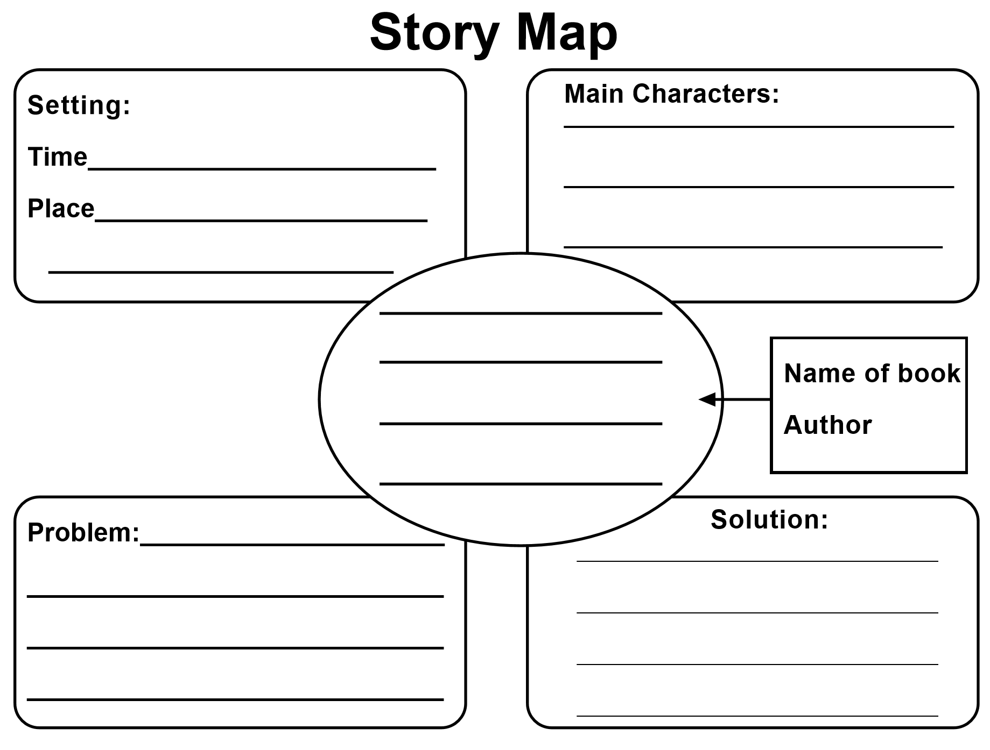
Story Map 1

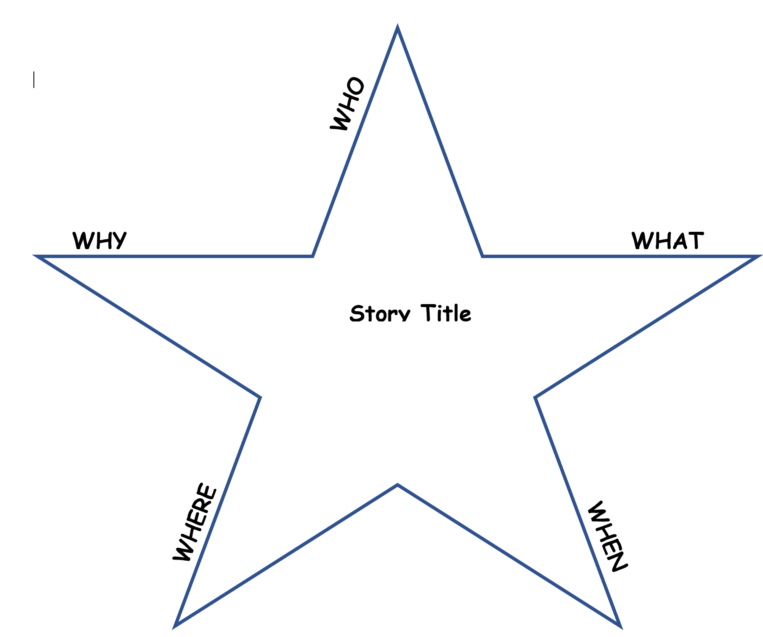
Story Map 2 – Semantic Star

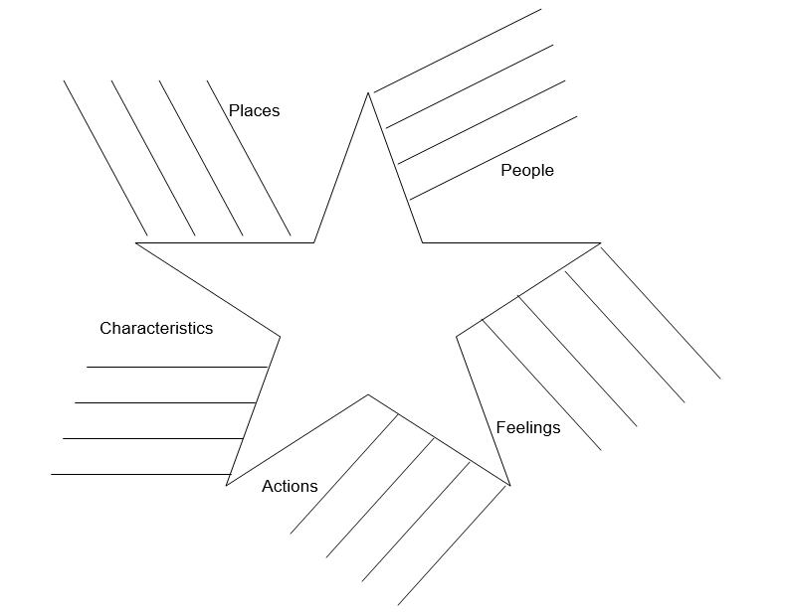
Story Map 3 – Semantic Star - Advanced

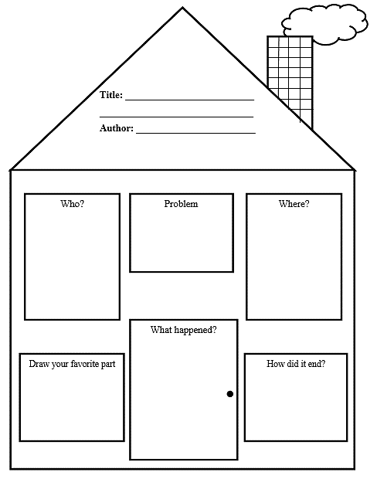
Story Map 4 - K-2

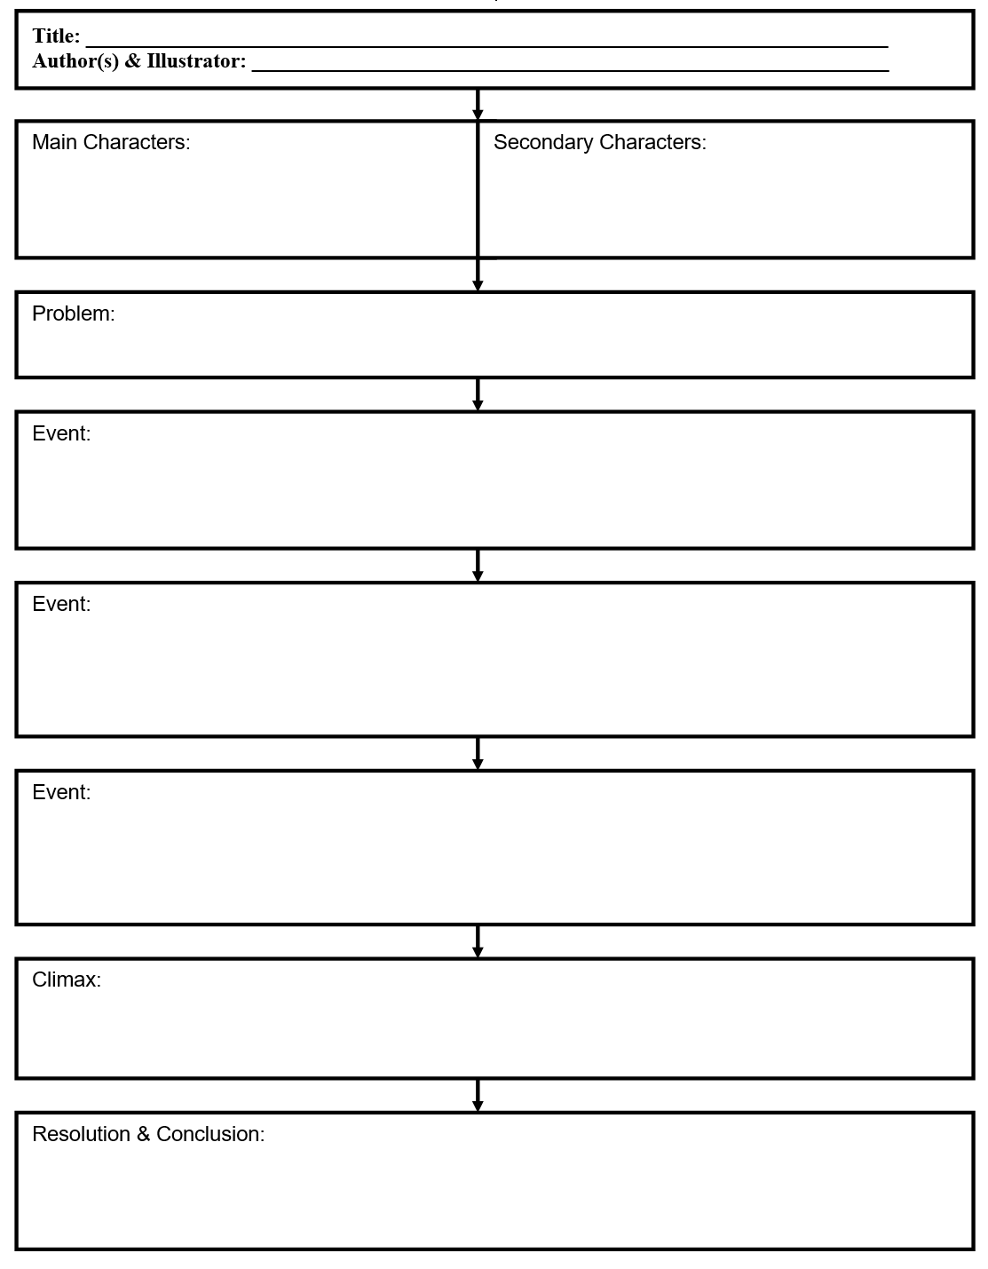
Story Map 5 – Grades 3-12

Enclosed Place
Discuss with your partner what it means to be “enclosed”
Basically it means that there is no way out and one does not need walls to be enclosed.

Examples:
- Realistic places (i.e. school, jail, airplane, etc.)
- Absurd places (i.e. ice cube, inside a book, etc.)
- Natural places (i.e. island, forest, cave, etc.)
- Social conditions (i.e. poverty, drug addiction, racism, etc.)
- States of Being – (i.e. love, hungry, insanity, mind etc.)

Writing Activity
- With your partner, decide which one of you is Writer A & which Writer B. Decide on an enclosed place where the two of you are trapped.
- Writer A “loves” the enclosed place. Writer B “hates” it.
- The “As” try to convince the “Bs” to stay and why this place is great. The “Bs” try to convince the “As” to leave and why it’s better to get out of the place.
- Share 1 piece of paper and in ten lines (Writer A writes five and Writer B writes five) each of you will try to convince the other of your point of view.
- There is one hitch! Neither of you may speak throughout the exercise.

Template
A: ___________________________________________________________________________
B: ___________________________________________________________________________
A: ___________________________________________________________________________
B: ___________________________________________________________________________
A: ___________________________________________________________________________
B: ___________________________________________________________________________
A: ___________________________________________________________________________
B: ___________________________________________________________________________
A: __________________________________________________________________________

B: ___________________________________________________________________________

Write at Home with Funny Situations
- The way this works is that you create a story starter.
- Try to use no more than 10 sentences.
- Make sure to include your kids’ names in the story.
- Then stop the story on a cliff hanger.
- The student/child then finishes the story.

Let’s try it…
- Read the following story starter, then take a minute a write the next two lines.

Annie, Kate, and Maria were driving home from a large conference. They decided to try a short cut through the Blue Ridge Mountains, but it was so rainy and foggy they couldn’t see where they were going.
- “Maria, are you sure you know the way home?”
- “Yes Kate, I know the way home. Annie gave me very clear instructions.”
- “I know I did, but this doesn’t look like the way I took last time. I think we missed the turnoff back there somewhere.”
- “Fine, I’ll stop at that rest stop up ahead and ask for directions.”
However, when the ladies pulled in, they noticed that the rest stop was all broken down and deserted. They decided to check inside in case someone had left an old roadmap posted.
- Kate looked around, “Maria let’s get out of here. This place is spooky.”
Maria and Annie turned around to answer Kate when suddenly they heard a loud…_________________
_________________________________________________________________________________________________________________________________________________________________________________________________________________________________________________________________________________________________________________________________________________________________________________________________________________________________________
_______________________________________________________________________________________________________________________________________________________________________________________________________________________________________________________________

Flipgrid Links
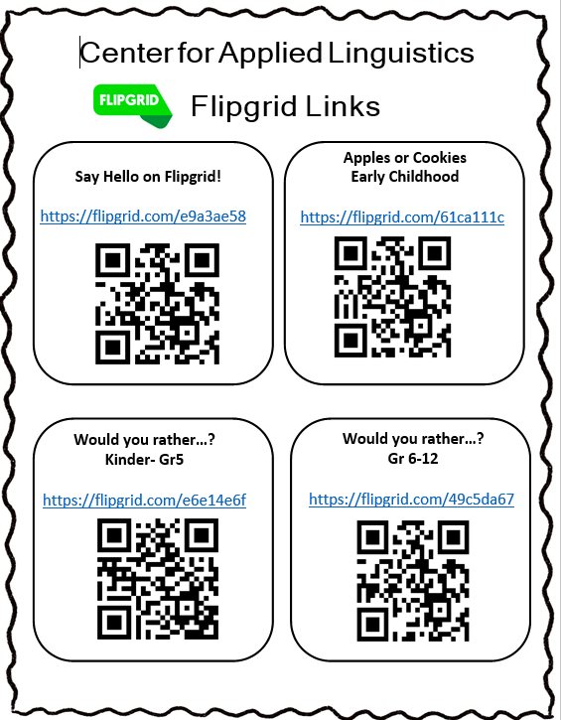
Flipgrid – Early Childhood
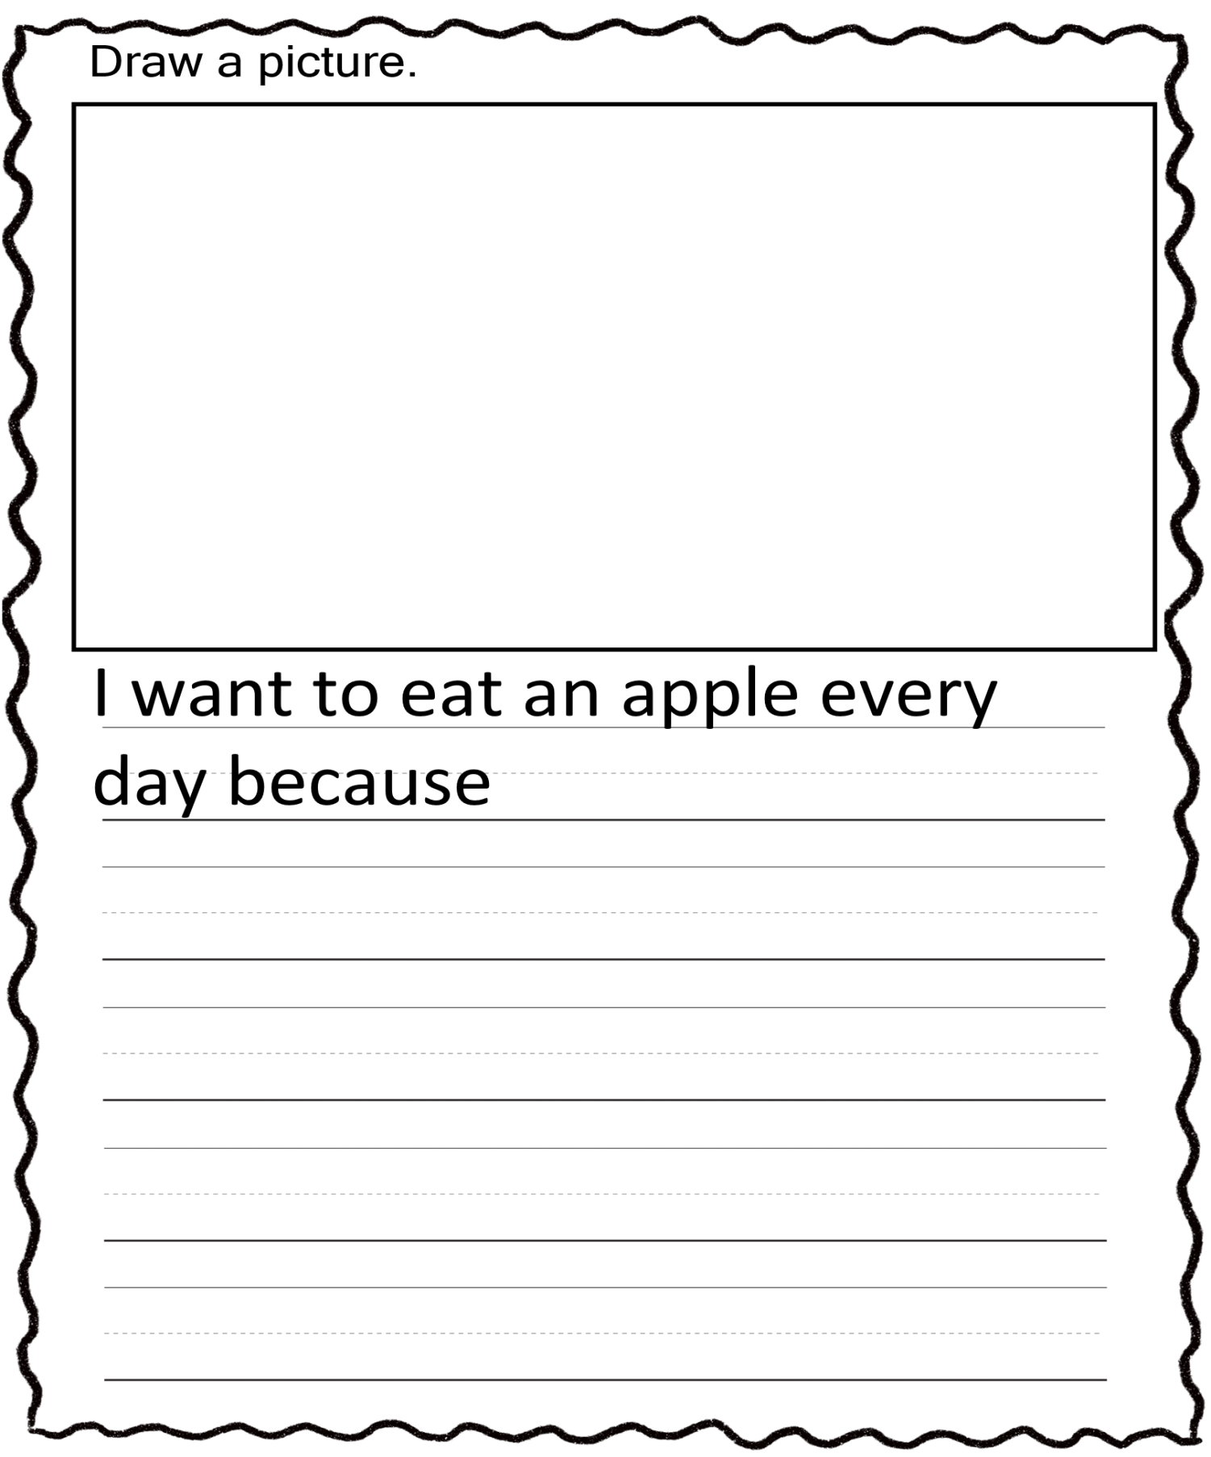

Flipgrid – Early Childhood
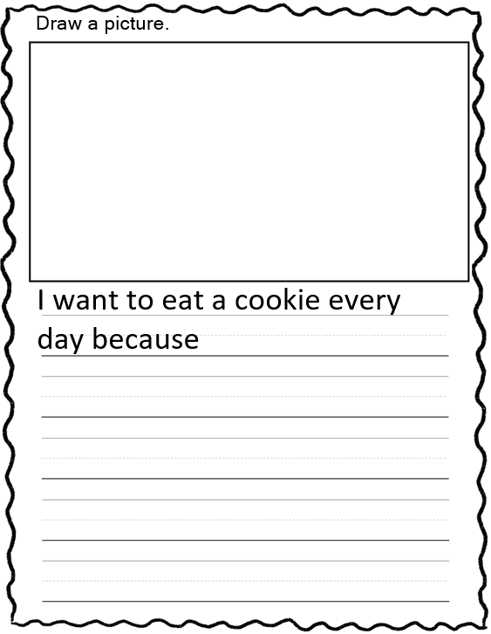

Flipgrid – K-5
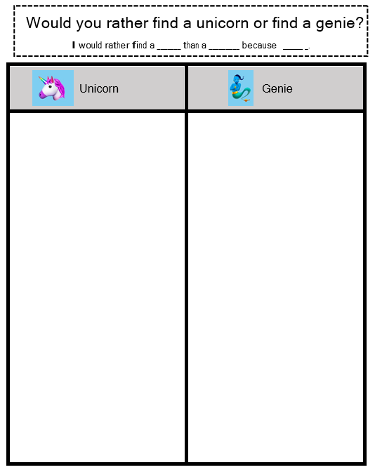
Flipgrid – K-5
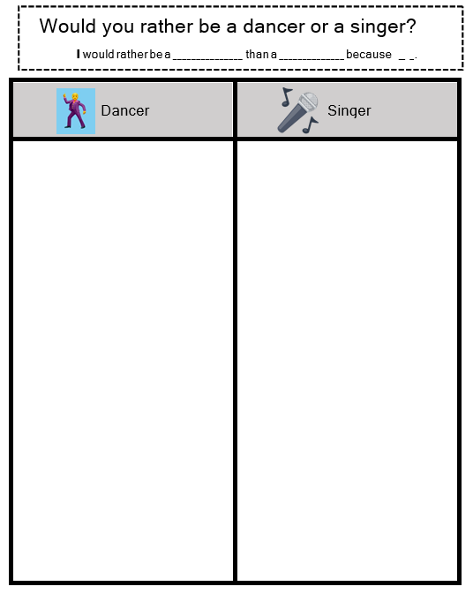
Flipgrid – K-5
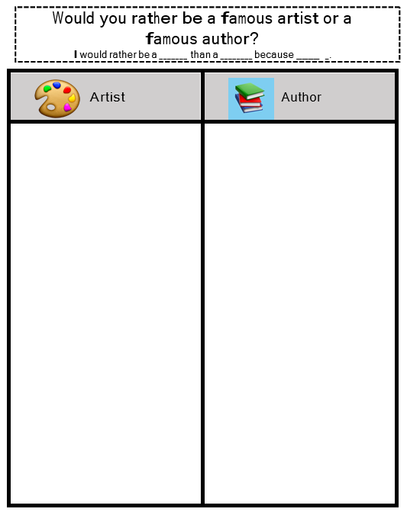
Flipgrid – K-5
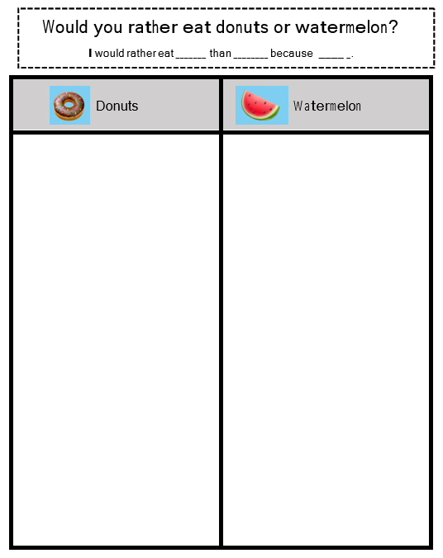
Flipgrid – K-5
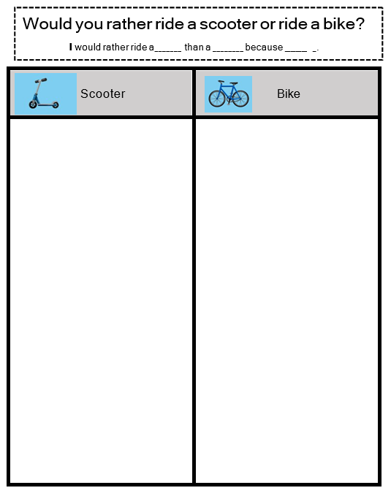
Flipgrid – K-5
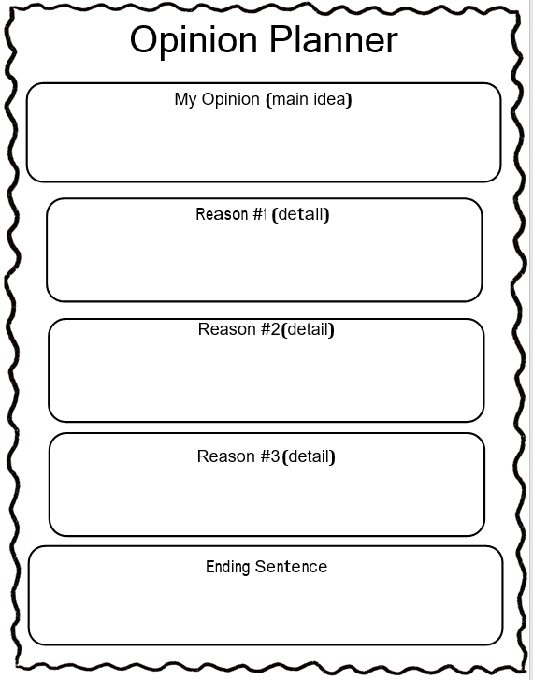
Flipgrid – 6-12
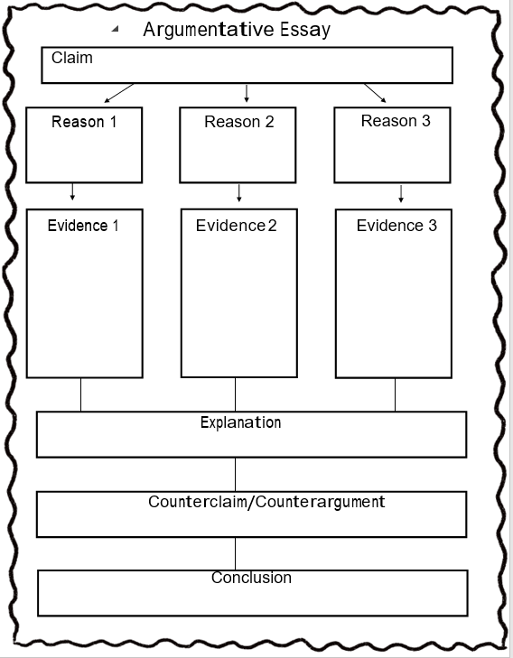
Flipgrid – 6-12
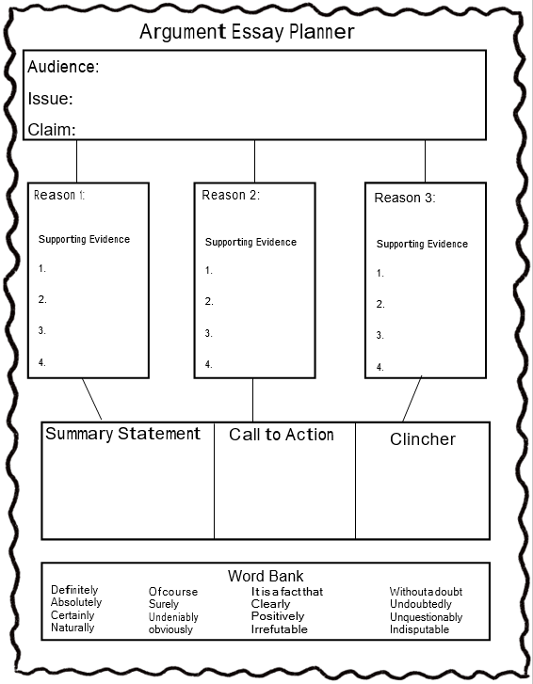
35 Writing Prompts - English
- What is your favorite holiday?
- What is your favorite season?
- This makes me really happy…
- When I grow up I want to be…
- My favorite television show…
- My school is cool because…
- What are you thankful for?
- How are you a good friend?
- How has someone helped you?
- How have you helped someone?
- My pet… (if you don’t have a pet, write about a pet you would like to have)
- Make a list of things you would need to take on a camping trip.
- If you could bring a character to life from either television or a story, who would it be?
- Who do you look up to and admire? What does it mean to be a good role-model? Is the person you wrote about a good role-model? Explain how.
- Which of the four seasons do you enjoy most?
- Which of the four seasons do you enjoy least?
- If you could make a new holiday, what would it be? How would you celebrate? What would you do?
- If you could choose to be trapped inside of a television show for a day which show would you choose?
- Create a list of “Would you Rather” questions. An example could be, “For one, day, would you rather be as small as an ant or as big as a dinosaur.
- If I were a teacher for a day…
- If you could be principal for the day at your school what would you do?
- What are the rules at your school? Do you see them as important? Would you change any? If you would change something be sure to explain why.
- What I like most about my home…
- If you had one hundred dollars but were not allowed to save it or spend it on yourself, what would you do with the money?
- Make a list of the important people in your life, If you could do something nice for these people, what would you do?
- If you could be any animal for a day which would you be, what would you do and why would you enjoy being this particular animal?
- Make “What If” statements… For example: what if dogs said, “Moo” instead of “Woof?”
- Write about your favorite school memory.
- My favorite family vacation. (If you’ve never been on vacation, tell where you would like to go.”)
- If you had three wishes what would you wish for and why?
- Explain what teamwork means.
- What sports have you played? If you’ve never played any sports, tell which you would like to try…
- My favorite things to do when I have free time…
- What are you favorite and lest favorite foods?
- Describe your best day ever.

35 Temas de Escritura – Español
- ¿Cuál es tu día festivo favorito?
- ¿Cuál es tu estación del año favorita?
- Esto me hace muy feliz…
- Cuando crezca quiero ser…
- Mi programa de televisión favorito…
- Mi escuela es genial porque…
- Me siento agradecido porque...
- Soy un buen amigo porque...
- Alguien me ha ayudado a...
- Alguien me ha ayudado con...
- Mi mascota… (si no tienes una mascota, escribe sobre una mascota que te gustaría tener)
- Haz una lista de cosas que necesitas llevar a un viaje de campamento…
- Si pudieras ser un personaje de la televisión o de una historieta, ¿Quién serías?
- ¿A quién respetas y admiras? ¿Qué significa ser un buen ejemplo? ¿Es la persona sobre la que escribiste un buen ejemplo? Explica porqué.
- ¿Cuál de las cuatro estaciones del año disfrutas más?
- ¿Cuál de las cuatro estaciones del año disfrutas menos?
- Si pudieras inventar un nuevo día festivo, ¿Cuál sería? ¿Cómo lo celebrarías? ¿Qué harías?
- Si pudieras elegir quedarte atrapado dentro de un programa de televisión por un día, ¿Cuál programa elegirías?
- Crea una lista de preguntas “¿Que preferirías?”. Un ejemplo podría ser, “Por un día, ¿Preferirías ser tan pequeño como una hormiga o tan grande como un dinosaurio?
- Si yo fuera maestro por un día…
- Si pudieras ser el director/a de tu escuela por un día, ¿Qué harías?
- ¿Cuáles son las reglas en tu escuela? ¿Piensas que son importantes? ¿Cambiarías alguna? Si pudieras cambiar algo, asegúrate de explicar por qué.
- Lo que más me gusta de mi hogar es...
- Si tuvieras $100, pero no se te permitiría guardarlo ni gastarlo en ti mismo, ¿Qué harías con el dinero?
- Haz una lista de personas importantes en su vida. Si pudieras hacer algo bonito para ellos, ¿Qué harías?
- Si pudieras ser un animal por un día, ¿Qué harías y por qué disfrutarías de ser este animal en particular?
- Escribe enunciados con “Y si” ... Ejemplo: ¿Qué pasaría si los perros hicieran, ‘mu’ en vez de ‘guau, guau,’?
- Escribe sobre su recuerdo favorito en la escuela.
- Mis vacaciones familiares favoritas… (Si nunca has ido de vacaciones, escribe sobre a donde le gustaría ir.)
- Si tuvieras tres deseos, ¿Cuáles serían y por qué?
- Explica el significado de trabajo en equipo.
- ¿Qué deportes has practicado? Si nunca has practicado algún deporte, ¿Cuál te gustaría intentar?
- Las cosas que más me gusta hacer cuando tengo tiempo libre…
- ¿Cuáles son tus comidas favoritas?, y ¿Cuáles son las que menos te gustan?
- Describe el mejor día de tu vida.

Rivera, C. (2012). Enclosed Place. New York, NY; Manhattan Theater Club

