**Promoting Oral Language Development**

1. Language Learning is Social Learning
2. Language Learning is Most Effective When the Environment is Supportive and Adapting
3. Language Learning Must be Meaningful, Purposeful, Authentic, and Cognitively Appropriate to the Learner
4. Language Learning Requires Comprehensible Input and Opportunities for Language Output

# Community Helper Bingo[1]

**Instructions:** Register for a free BrainPOP Family or School account. Choose Social Studies and the Community Helpers topic. Watch the video. Listen and pause the video to fill in the words or phrases below when you hear--or see--them.

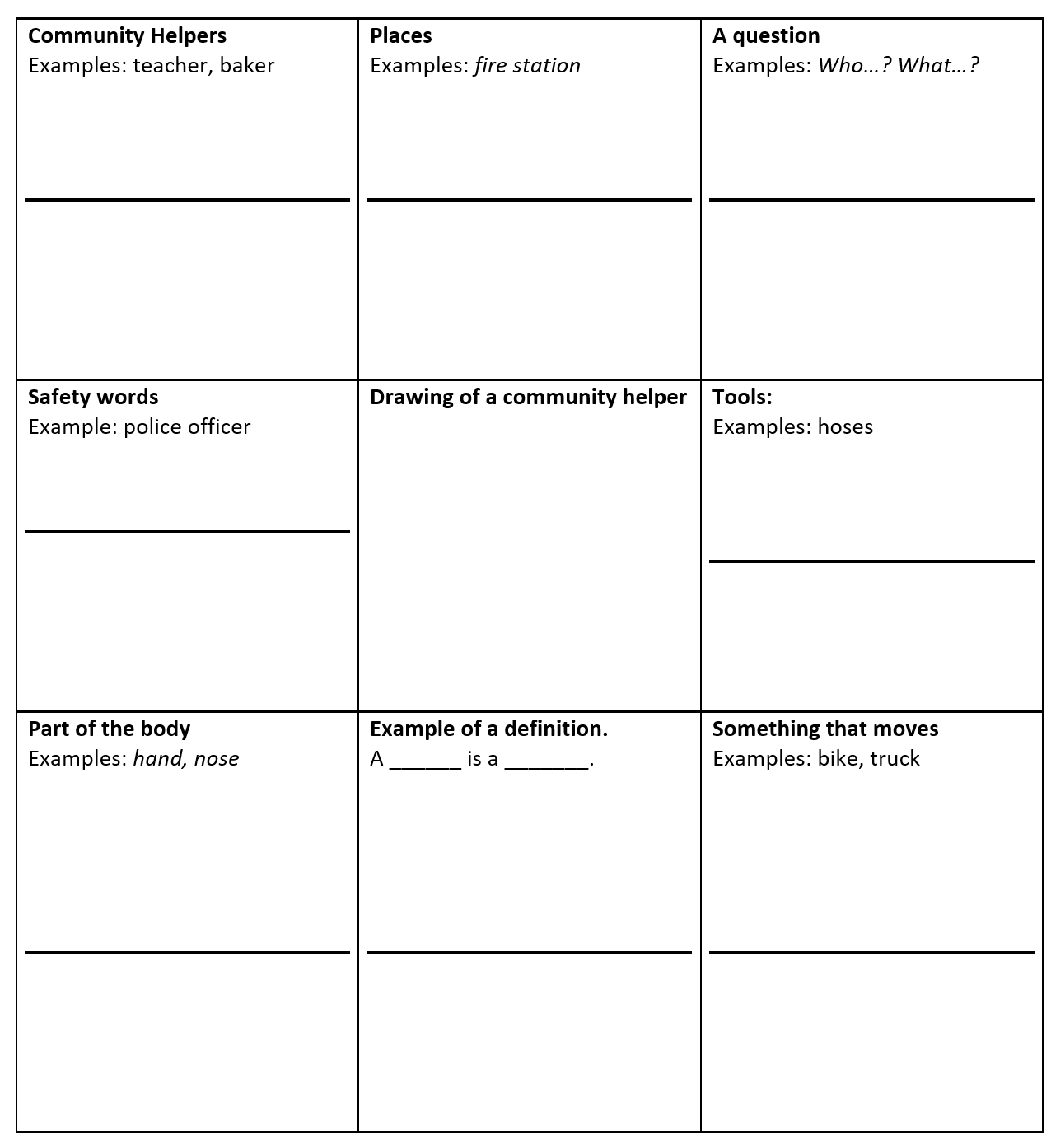

# Women’s History Month Bingo[2]

**Instructions:** Register for a free BrainPOP Family or School account. Choose Social Studies and the Women’s History topic. Watch the video about the artist, Georgia O’Keefe. Listen and pause to fill in the words or phrases below when you hear them.

|  |  |  |
| --- | --- | --- |
| **Places**  Examples: New Mexico, Hawaii | **Painting subjects**  Examples: *mountains, people* | **Style of art**  Examples: *abstract* |
| **Numbers** | **Drawing in a style of the artist.** | **Plural nouns:**  Examples: artists, brushes |
| **Past tense biography verb:**  Examples: *born, lived* | **Adjective (descriptive word or phrase):**  Examples: bright, jagged, influential | **Words or phrases that show time**  Examples: then, next, In 1940 |

# News Broadcast Bingo

**Instructions:** Listen to about 2 minutes of a news broadcast on TV or on the internet. The news must be spoken, but you can use closed captions. It is helpful if you can listen to the same clip multiple times and pause when needed. Alternatively, you could play this game over several different broadcasts. When you hear the type of word or phrase described on the bingo card, write your example on the line. Try to get three in a row across, down, or diagonally. All the examples provided come from various news broadcasts.

|  |  |  |
| --- | --- | --- |
| **Past tense verb:**  Examples: said, went, heard, ran, used, spoke | **Multi-word phrase**  Examples: social distancing, facts and fears, broad statements, between the ages, emergency stimulus package, very good result | **Word related to corona virus**  Examples: COVID-19, contagious, quarantine, testing  **________________________** |
| **Cause and effect language**  Examples: as a result, consequently, therefore, so | **Present tense verb**  Examples: see(s), come(s), work(s), say(s), use(s)  **__________________________** | **Collective or group noun:**  Examples: healthcare workers, the American people, the government, patients, the corona virus task force |
| **Words that show approximates**  Examples: almost, as much as, approximately, nearly, about, between, somewhere | **Descriptive word or phrase:**  Examples: vulnerable, elderly, amazing minds, aggressive research  **________________________** | **Compare and contrast language**  Examples: however, while, but, similar(ly), like, unlike, the same as, as much as |

**For an additional challenge, listen for these types of sentences.**

Did you hear a sentence that:

* makes a claim?

Example: *Donated blood is an essential part of caring for patients and one donation can save up to three lives.* (US Surgeon General news briefing)

_____________________________________________________________________________________

* uses persuasive language?

Example: *Social distancing does not have to mean social disengagement. So give blood today. You’ll feel good about it and you’ll be helping your country and your community during this crisis and you might even save a life.* (US Surgeon General news briefing)

_____________________________________________________________________________________

* describes a cause and effect?

Example: *All of this hinges on hospitals having enough supplies, which means hospitals are now rationing what they do have.* (CNN news report)

_____________________________________________________________________________________

* makes a prediction?

Example: *According to the most recent estimates, even in a moderate outbreak, 200,000 Americans will need intensive care and 64,000 will need ventilators.*

_____________________________________________________________________________________

**Information Gap: Animal Habitats Partner A**

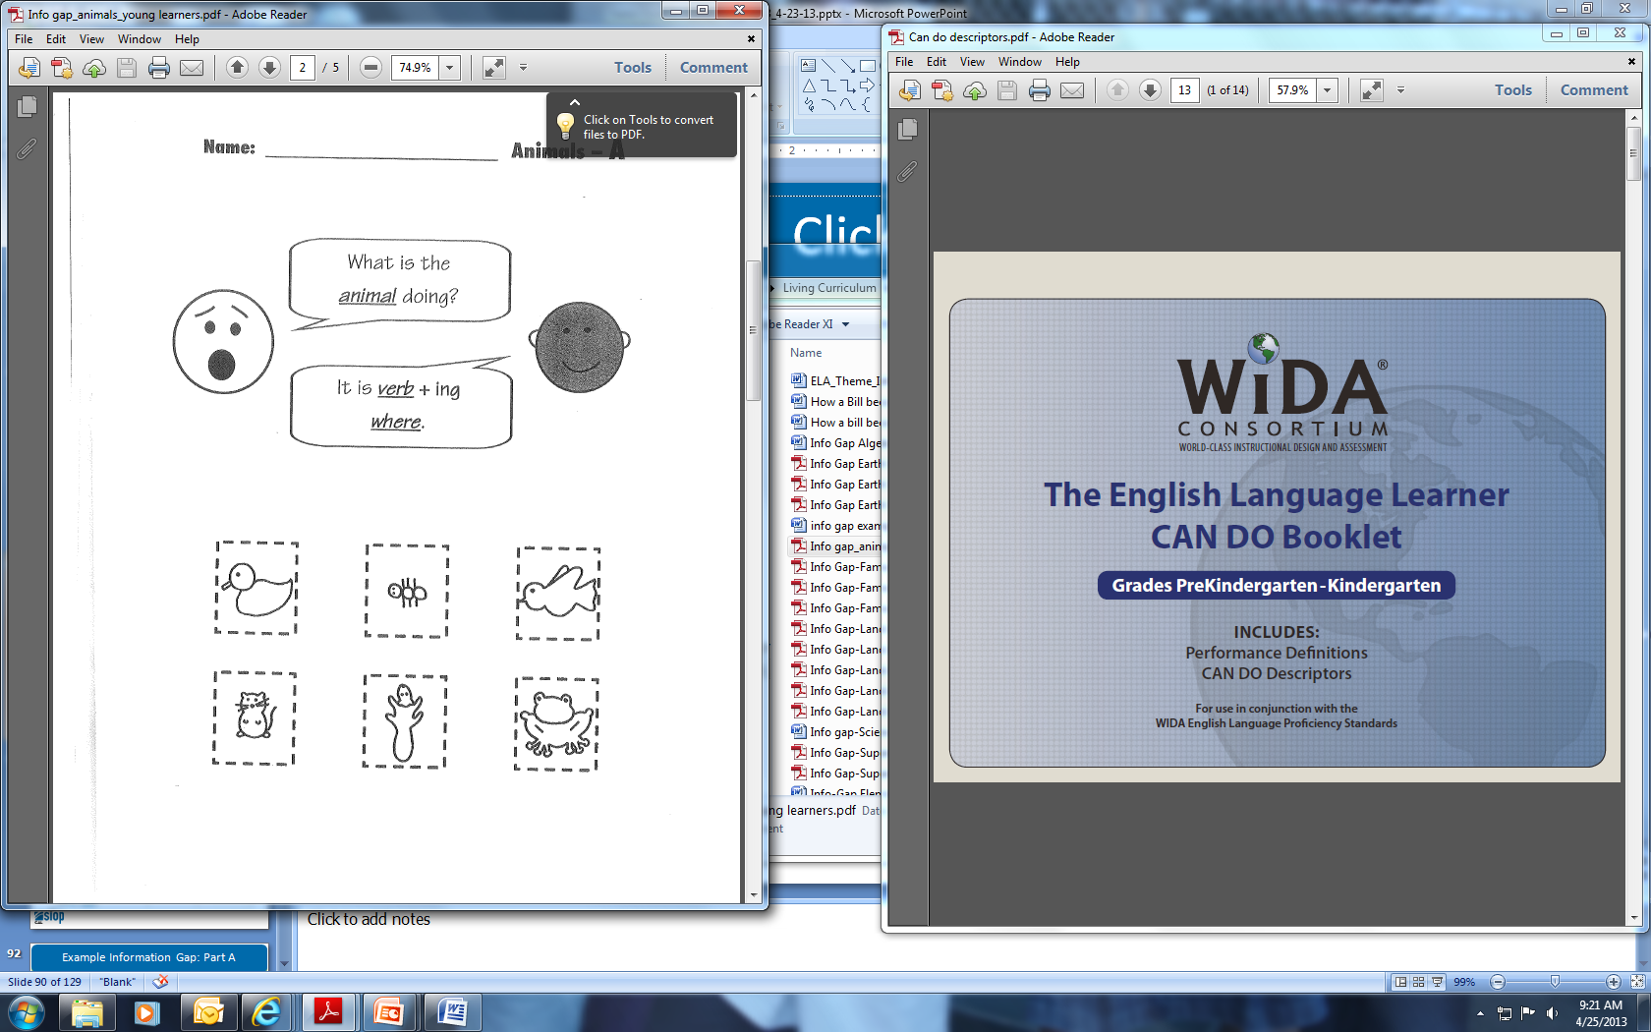

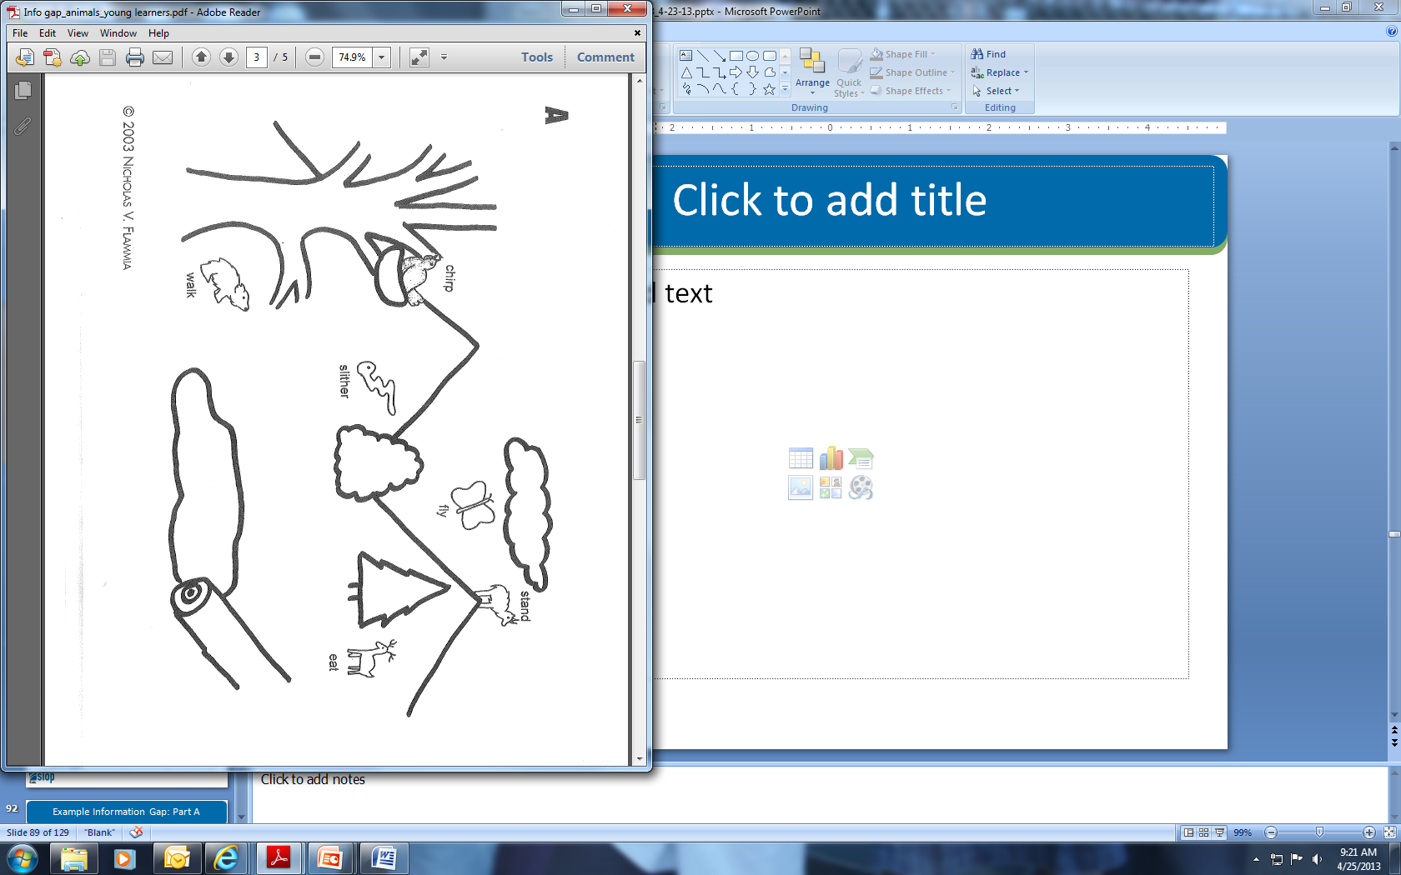**Information Gap: Animal Habitats Partner A[3]**

**Information Gap: Animal Habitats Partner B**

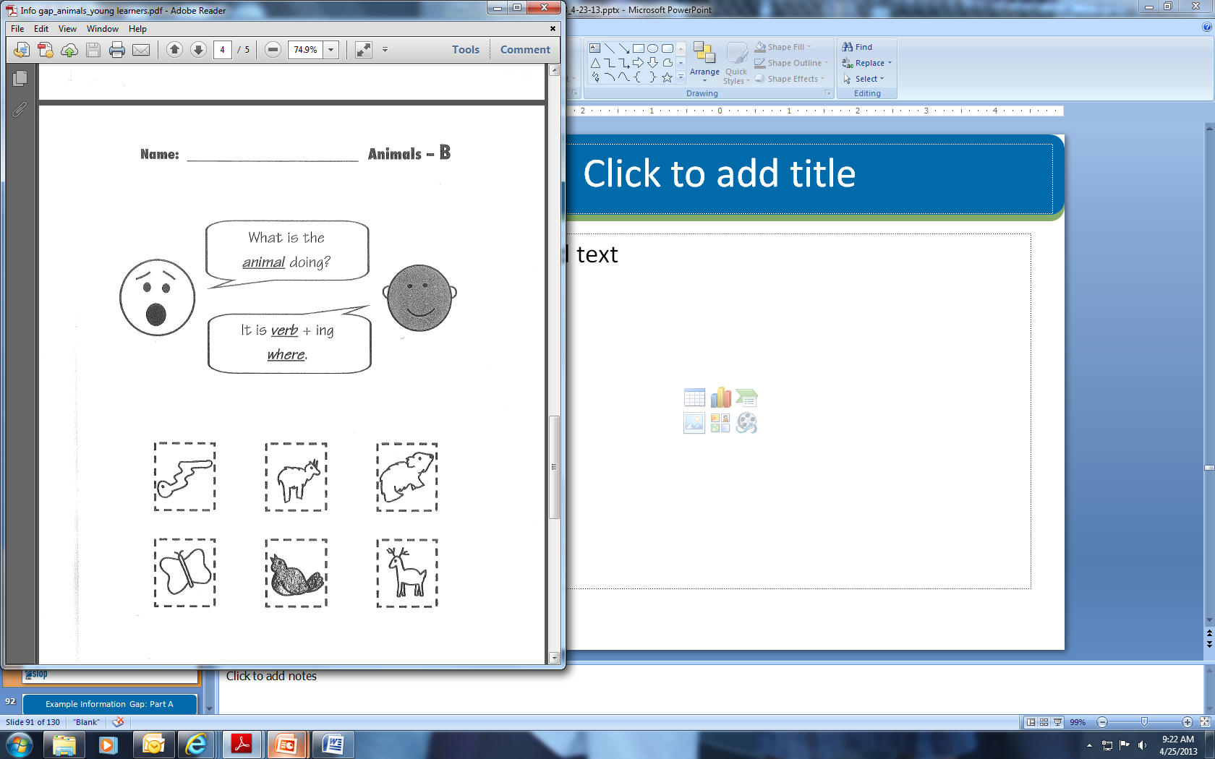

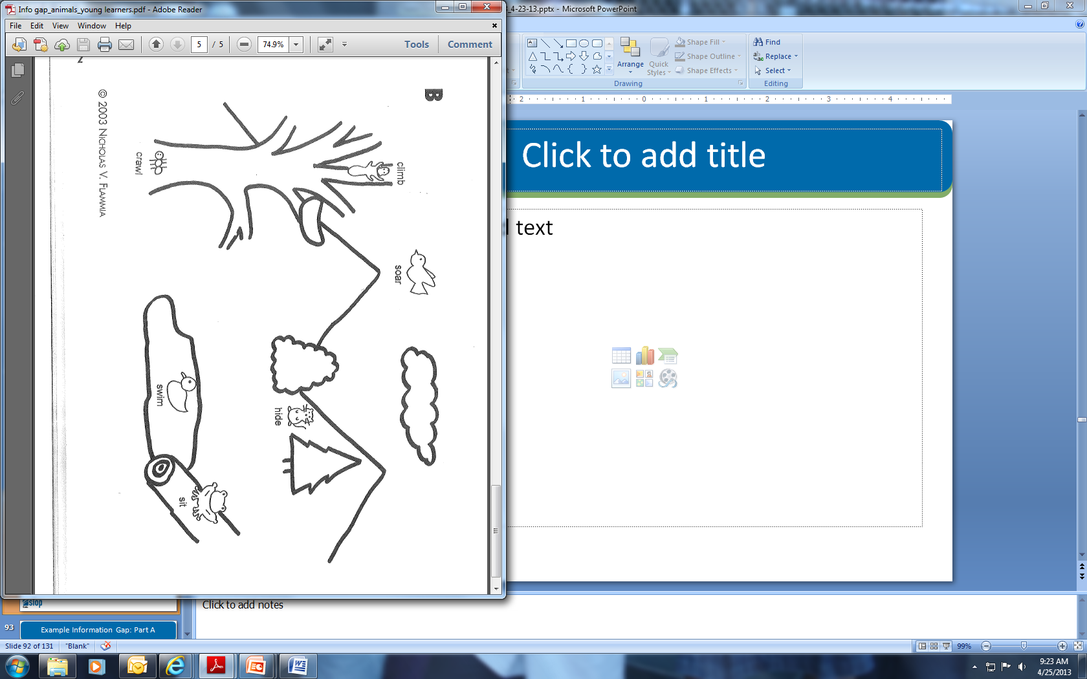**Information Gap: Animal Habitats Partner B[4]**

**Information Gap: Famous American Women**

**Sentence Frames**

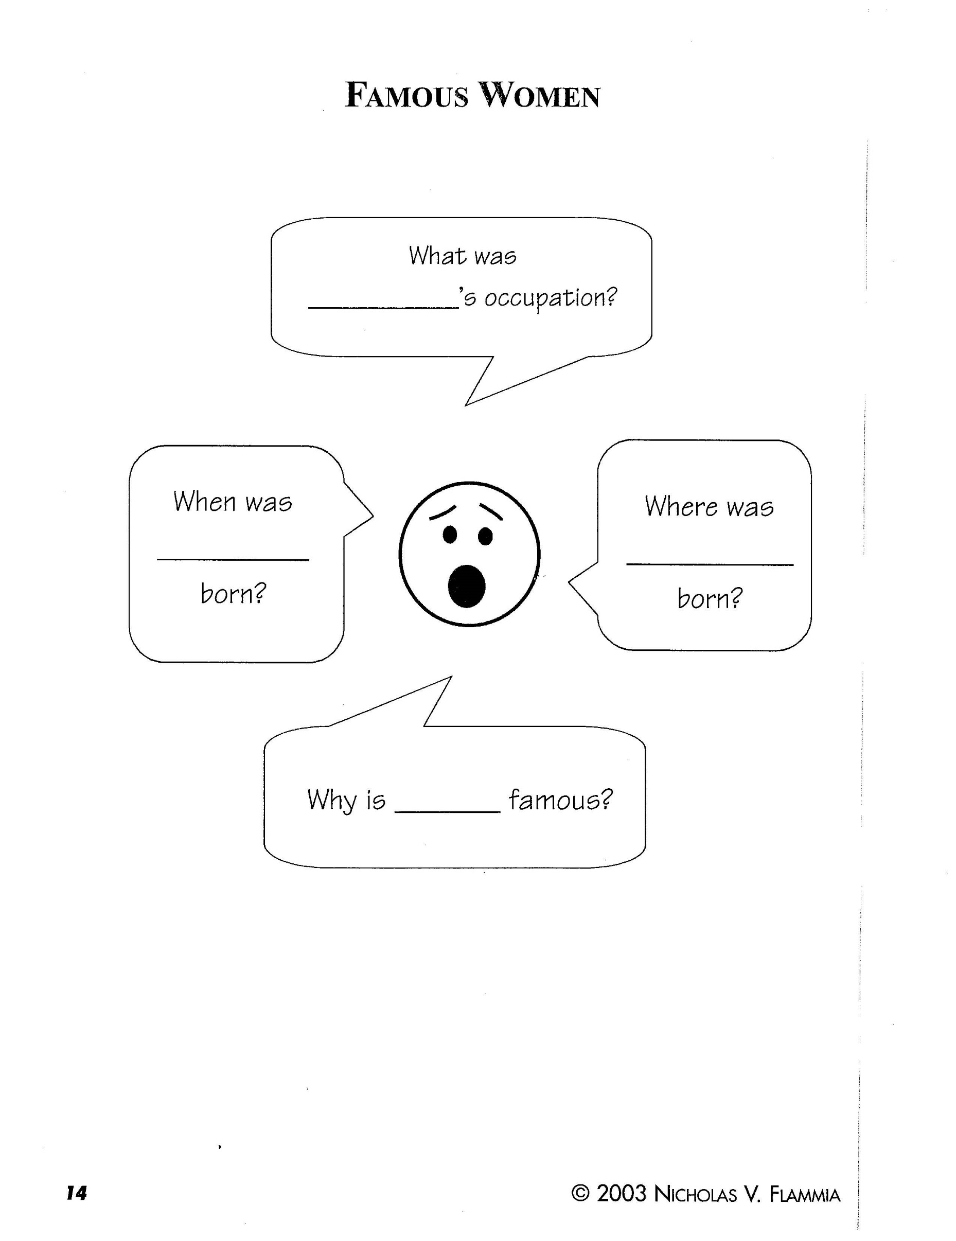

**Information Gap: Famous American Women - A[5]**

|  |  |  |  |  |
| --- | --- | --- | --- | --- |
| Name | Occupation | Birthplace | Date of Birth | Claim to Fame |
| **Helen Keller** | **Author –**  **a person that writes books** |  | **June 27, 1880** |  |
| **Jane Goodall** |  | **England** |  | **researched chimpanzees** |
| **Rosa Parks** | **Seamstress *–***  **a person that sews** |  | **February 4, 1913** |  |
| **Amelia Earhart** |  | **Kansas** |  | **was the first woman to fly by herself across the Atlantic Ocean** |
| **Sally Ride** |  |  | **May 26, 1951** | **was the first American woman to fly into space** |

**Information Gap: Famous American Women - B[6]**

|  |  |  |  |  |
| --- | --- | --- | --- | --- |
| Name | Occupation | Birthplace | Date of Birth | Claim to Fame |
| **Amelia Earhart** | **Aviator –**  **a person that flies airplanes** |  | **July 24, 1897** |  |
| **Rosa Parks** |  | **Alabama** |  | **fought for civil rights** |
| **Jane Goodall** | **Ethologist –**  **a person that studies animals** |  | **April 3, 1934** |  |
| **Sally Ride** | **Astronaut –**  **a person that trains to fly into outer space** | **California** |  |  |
| **Helen Keller** |  | **Alabama** |  | **was blind and deaf, yet learned to communicate** |

**Twenty Questions**

**Guesses**

1. ________________________________________________
2. ________________________________________________
3. ________________________________________________
4. ________________________________________________
5. ________________________________________________
6. ________________________________________________
7. ________________________________________________
8. ________________________________________________
9. ________________________________________________
10. ________________________________________________
11. ________________________________________________
12. ________________________________________________
13. ________________________________________________
14. ________________________________________________
15. ________________________________________________
16. ________________________________________________
17. ________________________________________________
18. ________________________________________________
19. ________________________________________________
20. ________________________________________________

1. https://jr.brainpop.com/socialstudies/communities/communityhelpers/
2. https://www.brainpop.com/socialstudies/womenshistory/
3. ©2003 Nichols V Flammia
4. ©2003 Flammia, N. V. (2003). *ESL information gap activities in the content areas*. McHenry, IL: Delta Publishing Company.
5. Flammia, N. V. (2003). *ESL information gap activities in the content areas*. McHenry, IL: Delta Publishing Company.
6. Flammia, N. V. (2003). *ESL information gap activities in the content areas*. McHenry, IL: Delta Publishing Company.