Brain Breaks
- Brain breaks are short, energizing bursts of activity that boost blood flow, send oxygen to the brain, and help kids better retain information.
- Simple 1-5 minute mind and body challenges
- Refresh your students’ minds through a controlled exercise break
- Excellent for regaining focus or giving hard working students a quick brain relaxing period where they do NOT have to think about instructional materials

Benefits of Brain Breaks
- Increase in productivity: Hitting pause long enough to give the Prefrontal cortex reprieve allows it to return to the task with renewed mental resources, increased creativity and motivation to refocus attention.
- Improved learning: Simple rest period allows for the hippocampus to review and ingrain recent knowledge to memory.
- Provides oxygen to the brain: Oxygen is vital to an active brain. 90% of the oxygen in our brain and body is stale until we take a deep breath or get up to move our bodies.
- Energizes mood: Brain breaks promote stretching, laughing, listening to music, meditation and positively interacting with peers, all of which increase restorative neurotransmitters like dopamine (a.k.a. the happiness hormone).
Williamson, B. (2020). Brain Breaks for the Classroom at Every Grade Band. Retrieved from Everfi.com

Types of Brain Breaks
- Relaxation and breathing brain breaks - designed to change the breathing pattern and facilitate oxygenation of the brain as well as calm the students.
- Highly physical brain breaks - designed to get the children up and moving vigorously to facilitate oxygenation of the brain and release tense muscles.
- Mathematics related activities - designed to promote a divergent thinking.
- Imaginary and creative play - Makerspaces, Genius Hour, and art projects to boost student’s imaginations

Weslake, A., & Christian, B. J. (2015). Brain breaks: Help or hindrance? TEACH COLLECTION of Christian Education, 1(1), 38-46.

Terada, Y. (2018). Research-tested benefits of breaks. Edutopia. Retrieved from https://www.edutopia.org/article/research-tested-benefits-breaks

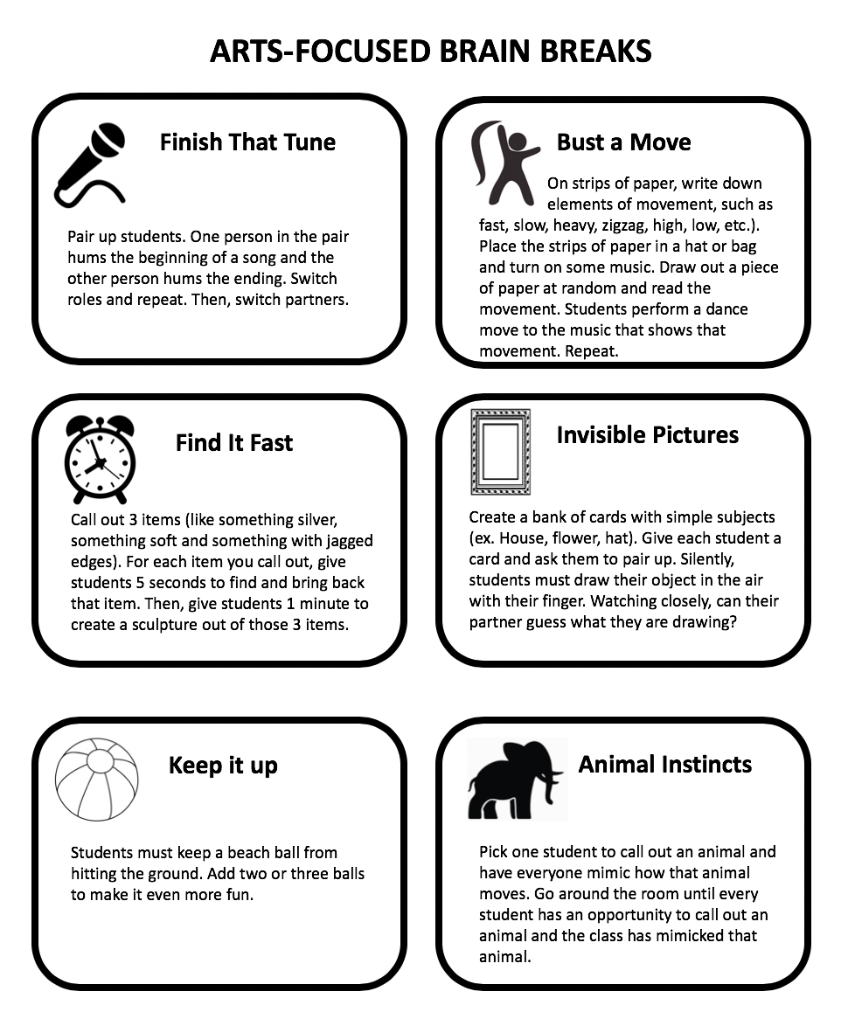
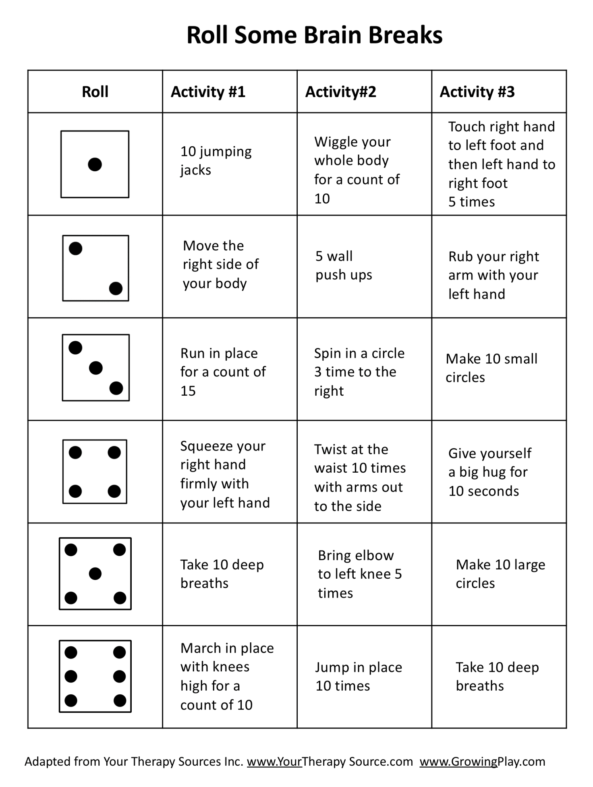

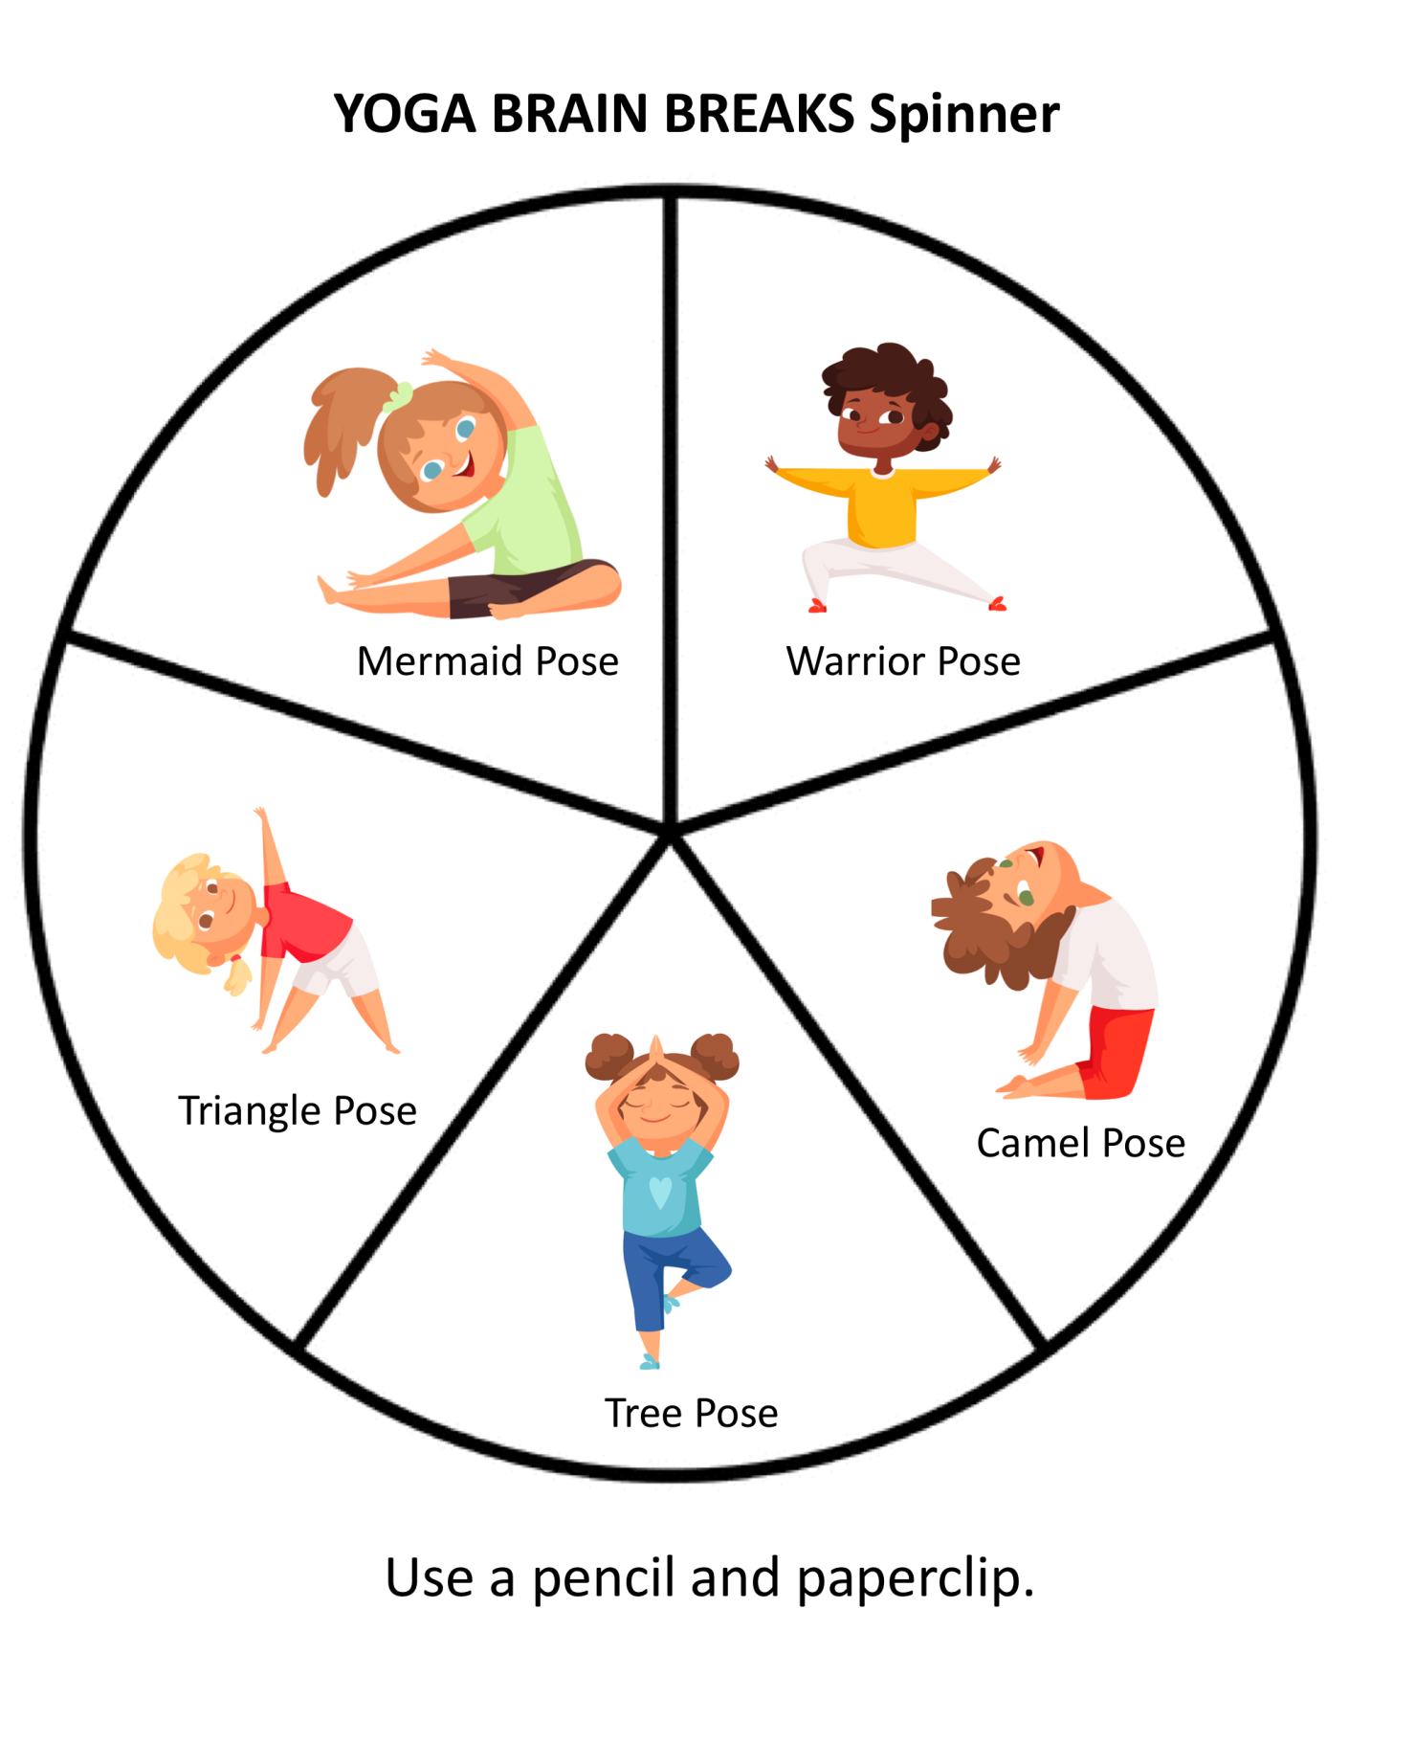

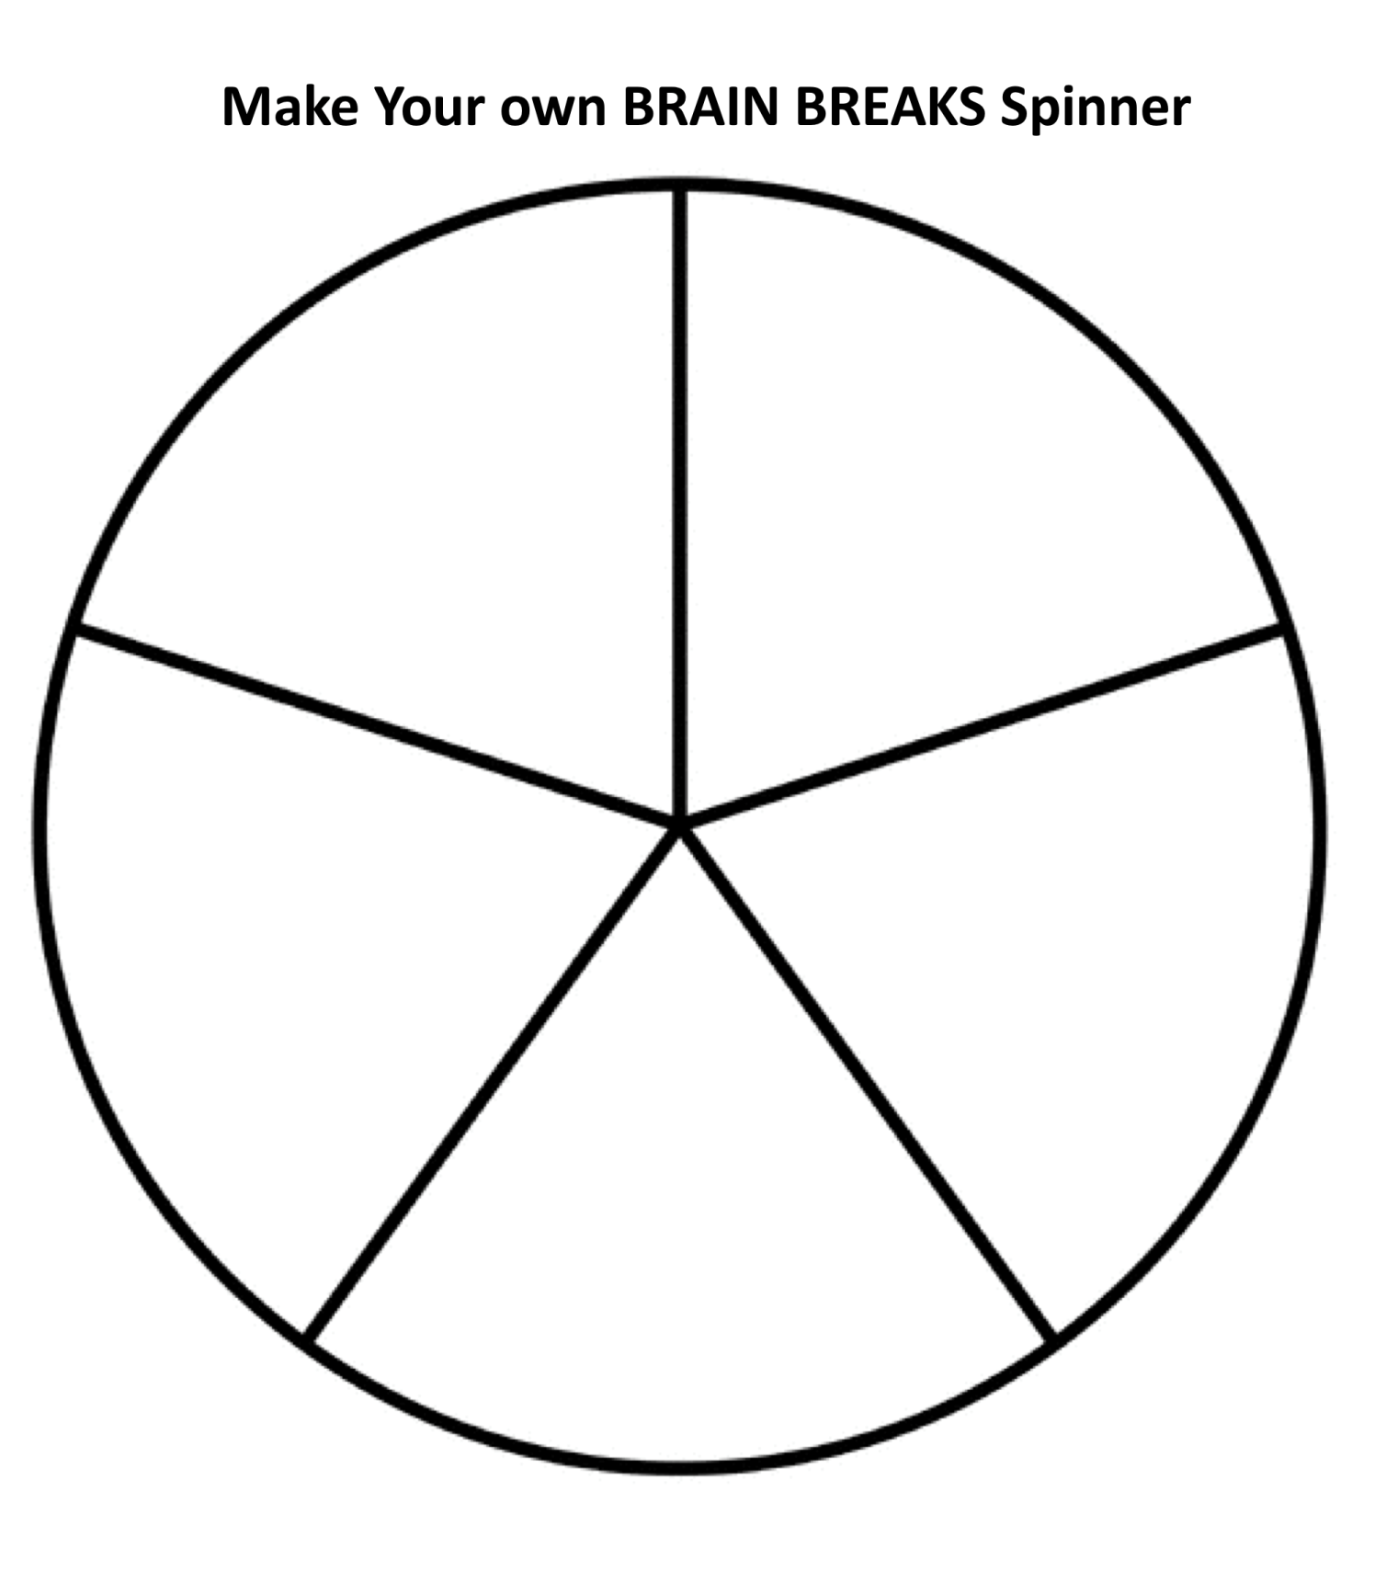
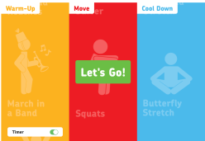
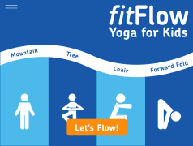
Brain Breaks Resources

- Fit.sanfordhealth.org
- FitBoost-Activity
- FitFlow Yoga for Kids
- Family.gonoodle.com
- Gonoodle.com/for-educators
- Movetolearnms.org
- http://puzzlemaker.discoveryeducation.com/

Brain Breaks Recommendations
- Explore a range of brain breaks to determine which is best suited to your students
- Weigh up the advantages and disadvantages of high enjoyment/high physical activities against the total time lost out of the lesson before implementing brain breaks of this nature
- Establish a routine of brain breaks in your classroom over an extended period of time before making judgements on their effectiveness

Primacy/Recency Effects
- The Primacy/Recency Effect is the observation that information presented at the beginning (Primacy) and end (Recency) of a learning episode tends to be retained better than information presented in the middle.
- During a learning episode, we tend to remember best that which comes first, and second best that which comes last.
- We tend to remember least that which comes just past the middle of the learning episode
- Rather than trying to fill an entire block period with one learning episode, a block can be divided into multiple learning episodes with brief breaks in between to maximize the proportion of prime-times to down times.
- New concepts or skills should be taught at the beginning of a lesson during prime learning time. Practice of the new material should occur during the down-time to help the learner organize it for further process.
- Closure should take place during prime-time 2 to provide students the opportunity to make sense and meaning of new learning.
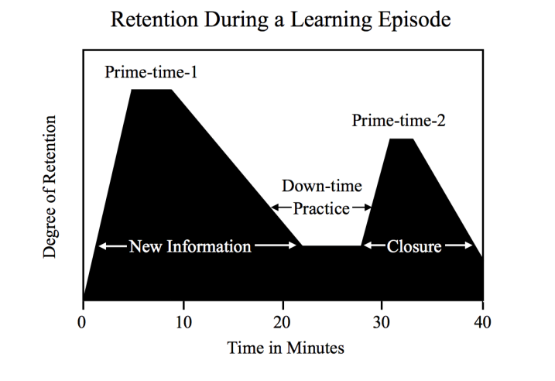
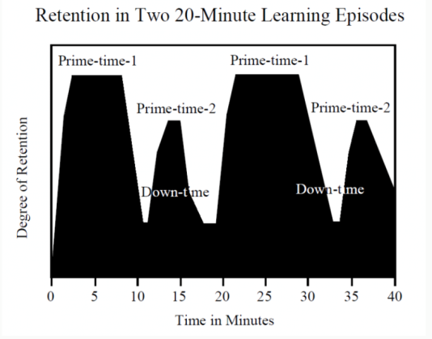

Sousa, David. (2006). How the Brain Learns. Thousand Oaks, CA: Corwin.

Coloring for Kids
- Benefits of Coloring for Kids:
  - Prepares them for school through the development and use of Tier 1 & 2 vocabulary
  - Opens venues for discussion and oral language development
  - Improves fine motor skills
  - Helps learn about boundaries, structure and spacial awareness
  - Teaches color awareness, recognition and discernment
  - Improves focus and hand to eye coordination
  - Improves confidence and self esteem
  - Helps self-expression and stimulates creativity
  - Contributes to better handwriting

Adult Coloring
- For older students & adults, coloring has a great many benefits
  - Reduce stress and anxiety
    - Coloring has the ability to relax the fear center of your brain, the amygdala. It induces the same state as meditating by reducing the thoughts of a restless mind.
  - Improve motor skills and vision
    - Coloring goes beyond being a fun activity for relaxation. It requires the two hemispheres of the brain to communicate. While logic helps us stay inside the lines, choosing colors generates a creative thought process.
- Improve sleep
- We know we get a better night’s sleep when avoiding engaging with electronics at night, because exposure to the emitted light reduces your levels of the sleep hormone, melatonin. Coloring is a relaxing and electronic-free bedtime ritual that won’t disturb your level of melatonin.
- Improve focus
  - Coloring requires you to focus, but not so much that it’s stressful. It opens up your frontal lobe, which controls organizing and problem solving, and allows you to put everything else aside and live in the moment, generating focus.
- Improves communication
  - As coloring reduces stress, it can also lower the affective filter that prevents second language learners from communicating effectively. While coloring, older students can utilize oral language skills to:
    - Speak with peers & adults about social topics while engaged in the activity
    - Focus on the artistic aspects of their activity in regards to lighting, shadows, perspectives
    - Use art based vocabulary when discussing their task
    - Connect their coloring with their culture and traditions
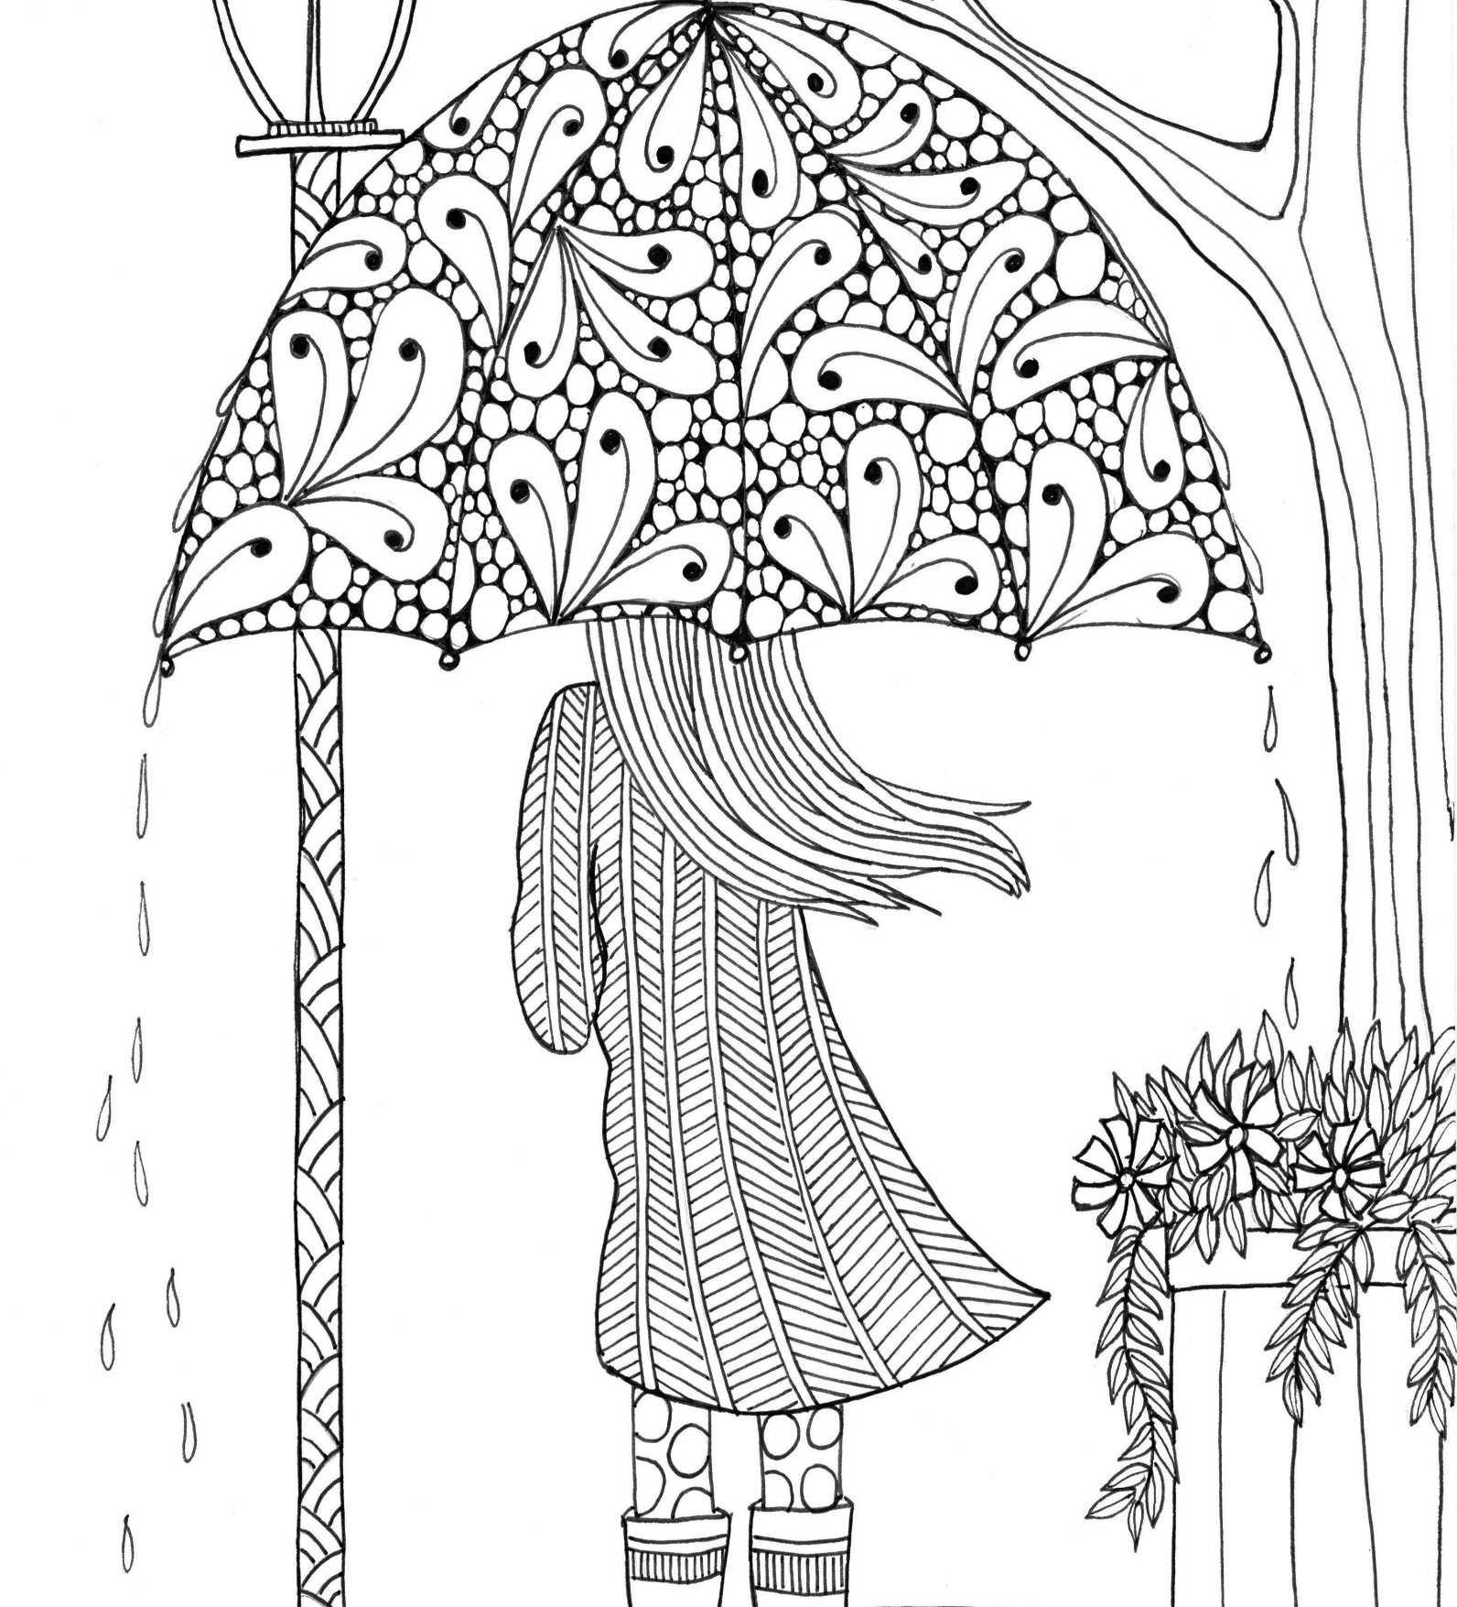

©2020 Getty Images

©2020 Getty Images
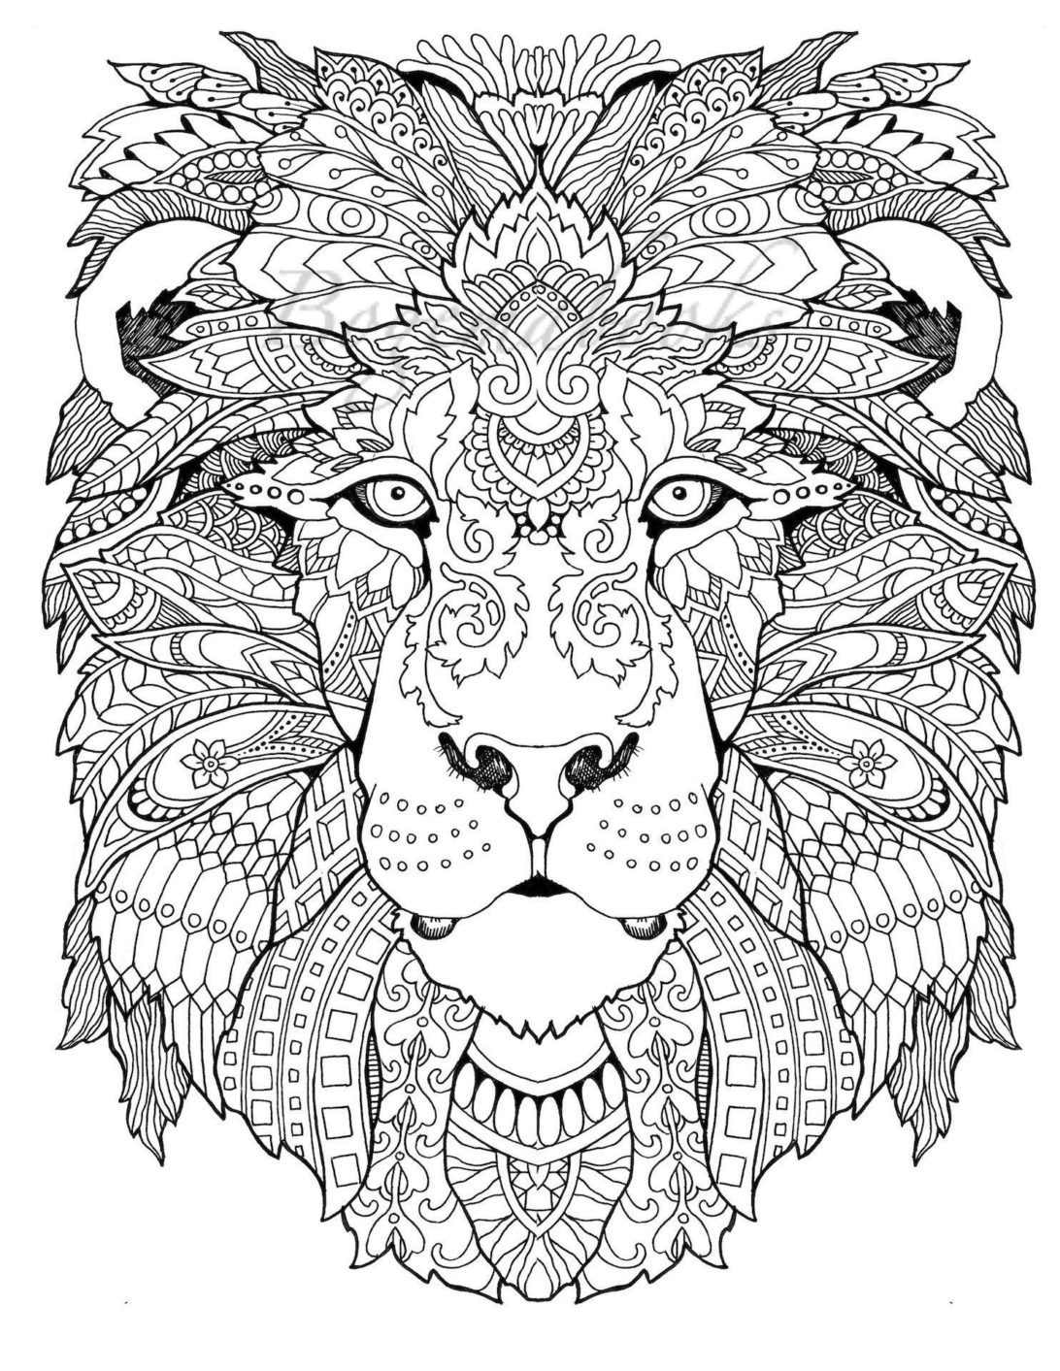

©2020 Getty Images

©2020 Getty Images
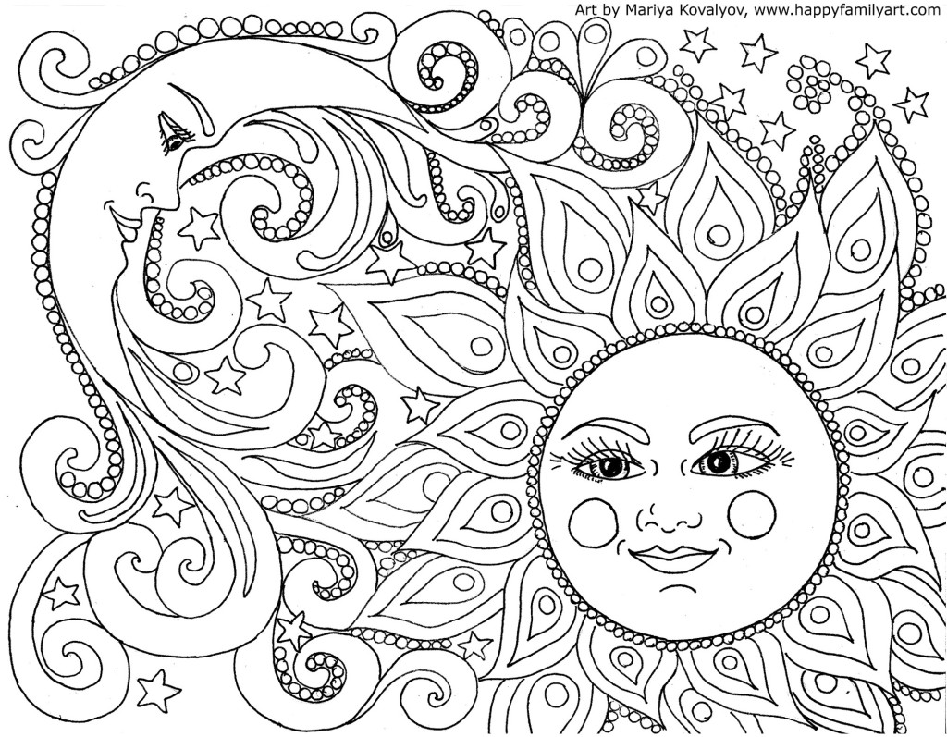
©2020 Getty Images

Art and Language: Simon Says Drawing

- Give learners simple drawing commands
  - Draw a square in the center of your paper
  - Draw a triangle on top of the square. Make sure the base or bottom of the triangle is the same width as the top side of the square.
  - Draw a small rectangle in the center of the square. The short side of the rectangle should touch the bottom of the square.
- After some commands, show your drawing and ask, "Does your drawing look like mine?”
  - How is it the same?
  - How is it different?
  - Why did you draw it that way?
- For a challenge, add the “Simon says” component where participants only follow commands preceded by “Simon says.”
- This activity help learners practice and reinforce listening skills
  - Directional language: left, right, up, down, top, bottom, side, center
  - Prepositions and prepositional phrases: on top of, beneath, over, above, around
  - Shapes, sizes: small triangle, large square
  - Comparative language: smaller than the square, the same size as the square on the left, similar to the one on the top
- Give a student a chance to be “Simon”
  - Practice giving commands
  - Give students an image to use with sentence frames
    - The ___ is on top of the _____.
    - Draw a ____ under the ______.
    - Make a ____ on the ____ side.
  - Practice the language before playing the game

Art and Language: You’re in the painting!

- Show learners some paintings of landscapes or scenes.
  - You can use famous paintings they might be familiar with.
  - Brainstorm vocabulary related to the painting before the activity
  - Pre-teach any vocabulary they might need
  - Choose a painting that corresponds to your lesson/unit topic to recycle and review content concepts and vocabulary
    - a time period in history
    - an art concept or style
    - a familiar topic or experience
- Have learners imagine that they are in the painting.
  - Why are they there?
  - What do they see?
    - create a Flipgrid video with their ideas
    - have a dialogue with another learner via text about the same image
    - write a story from their perspective within the painting
  - Provide supports like a word bank or sentence frames/stems:
    - I am _____ because ________. Looking around, I notice _____.
    - I feel _____ because _______. Something else I see is ________.

Art and language: Me! Collage

Creating a collage is a great way for learners to express themselves while their language proficiency develops

- Have learners create a collage all about themselves
- Put an image that represents them or a picture in the center
- Cut and glue images that are meaningful all around “me”
- Add descriptive words and phrases
- Learners can present their collages to their classmates
- Collages can be made digitally with photos, stock images and software like Adobe Photoshop

Mozart Listening Activity

Did you know that Twinkle Twinkle Little Star was a French folk song called Ah, vous dirai-je, maman? Mozart wrote Twelve Variations on this theme. Find a recording or watch the video clip linked below, performed by Rousseau. Listen first to the theme melody and then to each variation. What changed? Use the checklist below to identify what changed.

Key terms:
- Melody: a particular, identifiable association of notes and pitches; a tune.
- Rhythm: the element of music pertaining to time and expressed as grouping of notes into accented and unaccented beats, of beats into measures, etc.
- Dynamics: the loudness or softness of music

# Variation | Changes from the Theme
 | Melody | Rhythm | Dynamics | Description for the mood or character of the variation
Variation I
Variation II
Variation III
Variation IV
Variation V
Variation VI
Variation VII
Variation VIII

Variation IX
Variation X
Variation XI
Variation XII

Descriptive sample word bank for Mood:

quiet | rich | elegant | marching | rocking
soothing | full | soft | playful | jazzy
calm | mousy | serious | orchestral | slow

Which was your favorite variation? What did you like best about it?

_____________________________________________________________________________
_____________________________________________________________________________
Draw what this variation reminds you of:

Dena Przybyla (2019) Psychology of Color
Beaumont Hospital Group, Dearborn Michigan
Mozart’s Twelve Variations, performed by Rousseau: https://www.youtube.com/watch?v=hCKBl-TpRzc&list=RDhCKBl-TpRzc&start_radio=1&t=0

