Social Studies Language Tells Us a Story
- Historical accounts
- Historical recount
- Historical explanations
- Historical arguments
- Sources of information
- Conflicts and responses
- Analysis
- Chronology/timelines
- Political science
- Geographic factors & effects
- Political cartoons
- Any others you would like to add?

What do we need to take into consideration?
Some of the challenges that teachers face when helping English learners master social studies content are:

- Background knowledge ELLs may not have the same background knowledge that their peers have or that textbook authors take for granted
- Difficulty learning from textbooks. In social studies texts, facts and details are often condensed and authors often omit the type of concrete or anecdotal detail that can help ELs relate to unfamiliar concepts from their own experiences. Textbooks often contain a high concentration of new and complex vocabulary or sophisticated sentence structure
- Difficulty learning from lectures. Some ELs find it difficult to understand different teachers’ accents and pronunciations. Others may have lived in the U.S. too short a time to have developed sufficient listening skills. Social Studies vocabulary plays various roles depending on the context. Using words from idioms, political cartoons, or vernacular to the academic style is tricky.
- Different perspectives - ELs bring their own valuable and important experiences to the classroom. Often those experiences can be connected to the content in meaningful ways; however, if different points of view or ideas aren't expressed or identified, students will miss key concepts and ideas in the lesson.
- Academic language and vocabulary ELs must learn the academic language and vocabulary needed to comprehend and produce new content — all while learning the new content and concepts at the same time!

Voices from the Field

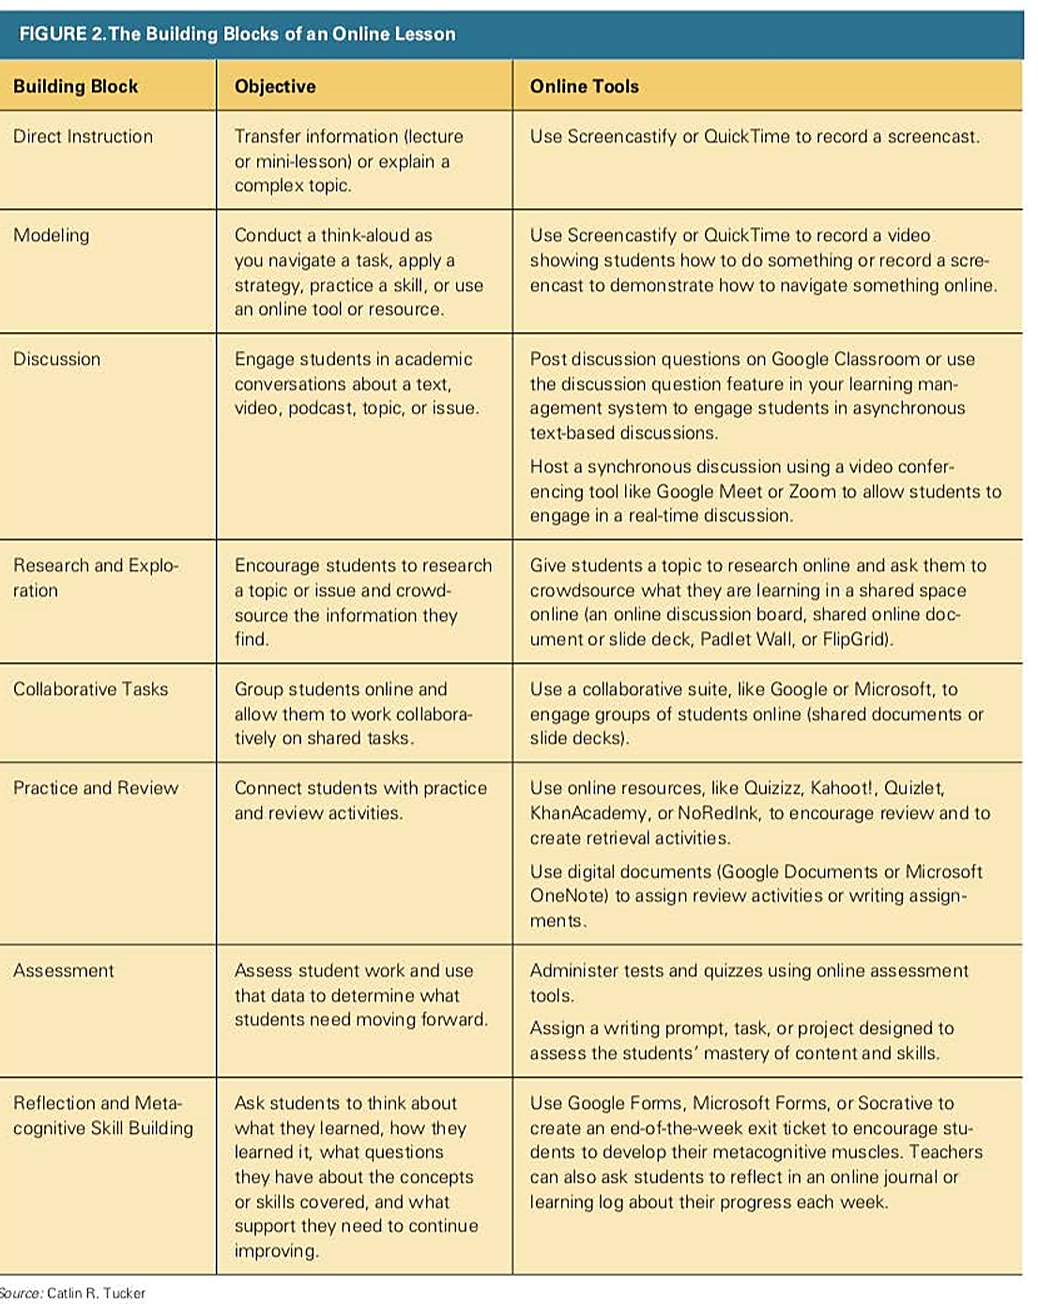

Google Lit Trips
- A collection of immersive 3D literary field trips where students virtually become traveling companions with characters in stories commonly taught in grades Kindergarten through high school
- Visit Googlelittrips.org
- Install Google Earth on a computer

One-Time Only Google Lit Trip Member Registration
- Go to Google Lit Trips website (https://www.GoogleLitTrips.org)
- Upon submitting your registration an automated confirmation email from GLT Global ED
- A donation is NOT necessary to request a Lit Trip
- Make sure you have Google Earth installed to use the Google Lit Trip

Requesting a Google Lit Trip
- Grade level groupings are approximations. You may find titles of interest in the grade levels just above or below the actual grade level you teach.
- After you requested a Lit Trip, click on the automated email from GLT Global ED. Google Earth will automatically open your requested Google Lit Trip ready to present
K-5 Titles | 6-8 Titles | 9-12 Titles
Abuela  Are We There Yet  Bud Not Buddy  Number the Stars  Pedro’s Journal  We All Went on Safari  The Yellow Balloon  Riding Freedom  The Armadillo from Amarillo  Make Way for Ducklings  Bonyo Bony  Paddle tot the Sea  A Small Dog’s Big Life  I Spy New Zealand  Amy’s Travels | Walk Two Moons  Esperanza Rising  Fever 1793  Journey to Topaz  Marching for Freedom  Sugar Changed the World  Remote Man  The Slave Dancer  Underground to Canada  The Sisterhood of the Traveling Pants  The Watson Go to Birmingham  Blood on the River  Hana’s Suitcase | The Kite Runner  Frankenstein  Ann Frank: The Diary of a Young Girl  In Search of Beowulf  Macbeth  Night  The Aeneid  The Catcher in the Rye  The Grapes of Wrath  The Odyssey  Farewell to Farewell to Manzanar  Hiroshima  Things That Must Not Be Forgotten

Transition Words
Cause and Effect
- Therefore
- So
- Because
- Thus
- Since
- Hence Due to
- As a result of
- Consequently
- Due to
- In order to
- If…then…
Transition Words
Comparison
- In the same way
- In like manner
- Similarly
- Like
- Equally
- For the same reason
- Similar to
- As compare to
- Likewise
Transition Words
Contrast
- But
- However
- Otherwise
- Unlike
- Conversely
- In spite of
- At the same time
- On the other hand
- Sometimes
- Nevertheless
- In contrast

Family Language Tree
- Interview family members about the languages they speak or learned
    - Why did they learn/acquire the language(s)?
    - How did they use the language(s)?
    - What was their proficiency levels of each language acquired/learned?
- Create a family language tree using a family tree template
- Extension Activities
- Create a family history report, scrapbook, audio book, website to share with family and classmates
- Create a map with pins to track the languages or the places where your family members acquired the language

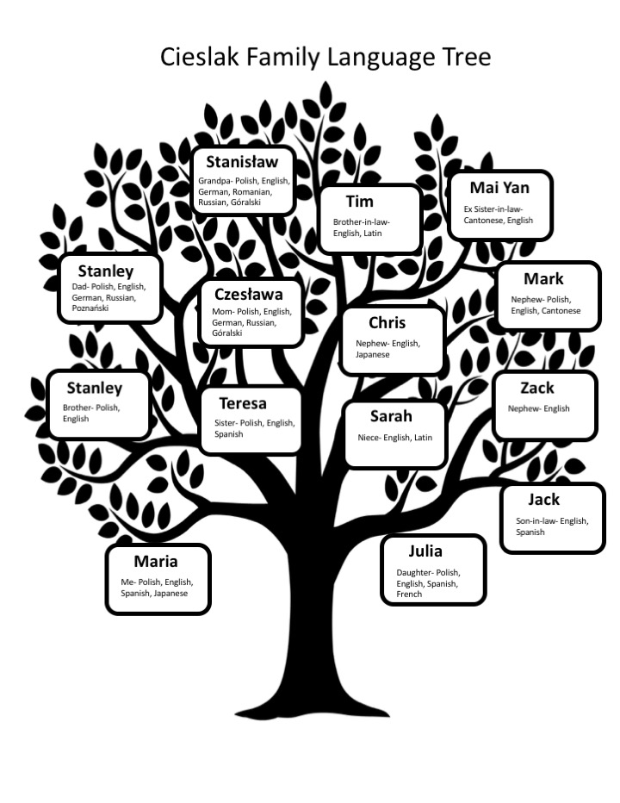
Example of Family Language Tree

Family Language Tree

Oral History

- Have students select a family member to interview as well as a time period/topic.
- Have students research the time period/topic and write 6-12 questions, depending on their grade levels.
- Have students bring artifacts and pictures to amplify the discussion.
- Have students interview their family members via phone, conference platforms or other apps.
- Mini-lessons may include:
    - Selecting sources about the time period/topic.
    - Developing open-ended questions.
    - Asking follow-up questions.

Oral History Project Brainstorming Sheet

Name: ______________________________Interviewee: ______________________

Subject of interview: world event: ____________ personal experience:________

Time period: _______________

Facts about this time period | Artifacts to bring/share
Possible Questions:
Oral History Project Note-Taking Sheet

Name: _____________________________Interviewee: ________________________

Subject of interview:_________________________ Time period: _______________

Questions | Answers
Play Risk to Learn Geography

- Materials
    - Table top map of your choice
    - Player tokens of different colors/types representing army troops
    - If 2 are playing, each gets 50 troops
    - If 3 are playing, each gets 35 troops
    - If 4 are playing, each gets 30 troops
    - If 5 are playing, each gets 25 troops
    - Set of cards naming each continent, country, or territory depicted on the map. If you are including waterways, you might want to add tokens for navel vessels and cards depicting the waterways.
    - 5 dice – 3 of one color (i.e. red) 2 of a different color (i.e. white)
Tokens can be any available materials: game board pieces, dried beans, Lego® pieces, bingo chips, jacks, clay balls or shapes, colored card stock. Anything to take up space.

- Simplified Rules:
- Roll one die. Whoever rolls the highest number takes one token from his or her pile and places it onto any territory on the board, claiming that territory.
- After all territories are claimed, each player in turn places one additional army onto any territory he or she already occupies.
- Continue in this way until everyone has run out of tokens. There is no limit to the number of tokens you may place onto a single territory.
- You, the attacker, will roll 1, 2 or 3 red (colored) dice: You must have at least one more army in your territory than the number of dice you roll.
- The defender will roll either 1 or 2 white (other colored) dice: To roll 2 dice, he or she must have at least 2 armies on the territory under attack.
- Compare the highest die each of you rolled. If yours (the attackers) is higher, the defender loses one army from the territory under attack. But if the defender's die is higher than yours, you lose one army from the territory you attacked from
- Winner is the person who wins the most territories.

Geography Twister

- Each player spins 2x. First time for location, the second time for the body part.
- Then they step/touch on the appropriate geographic site with the indicated body part (foot or hand).
- Then find and label a globe or blank map.
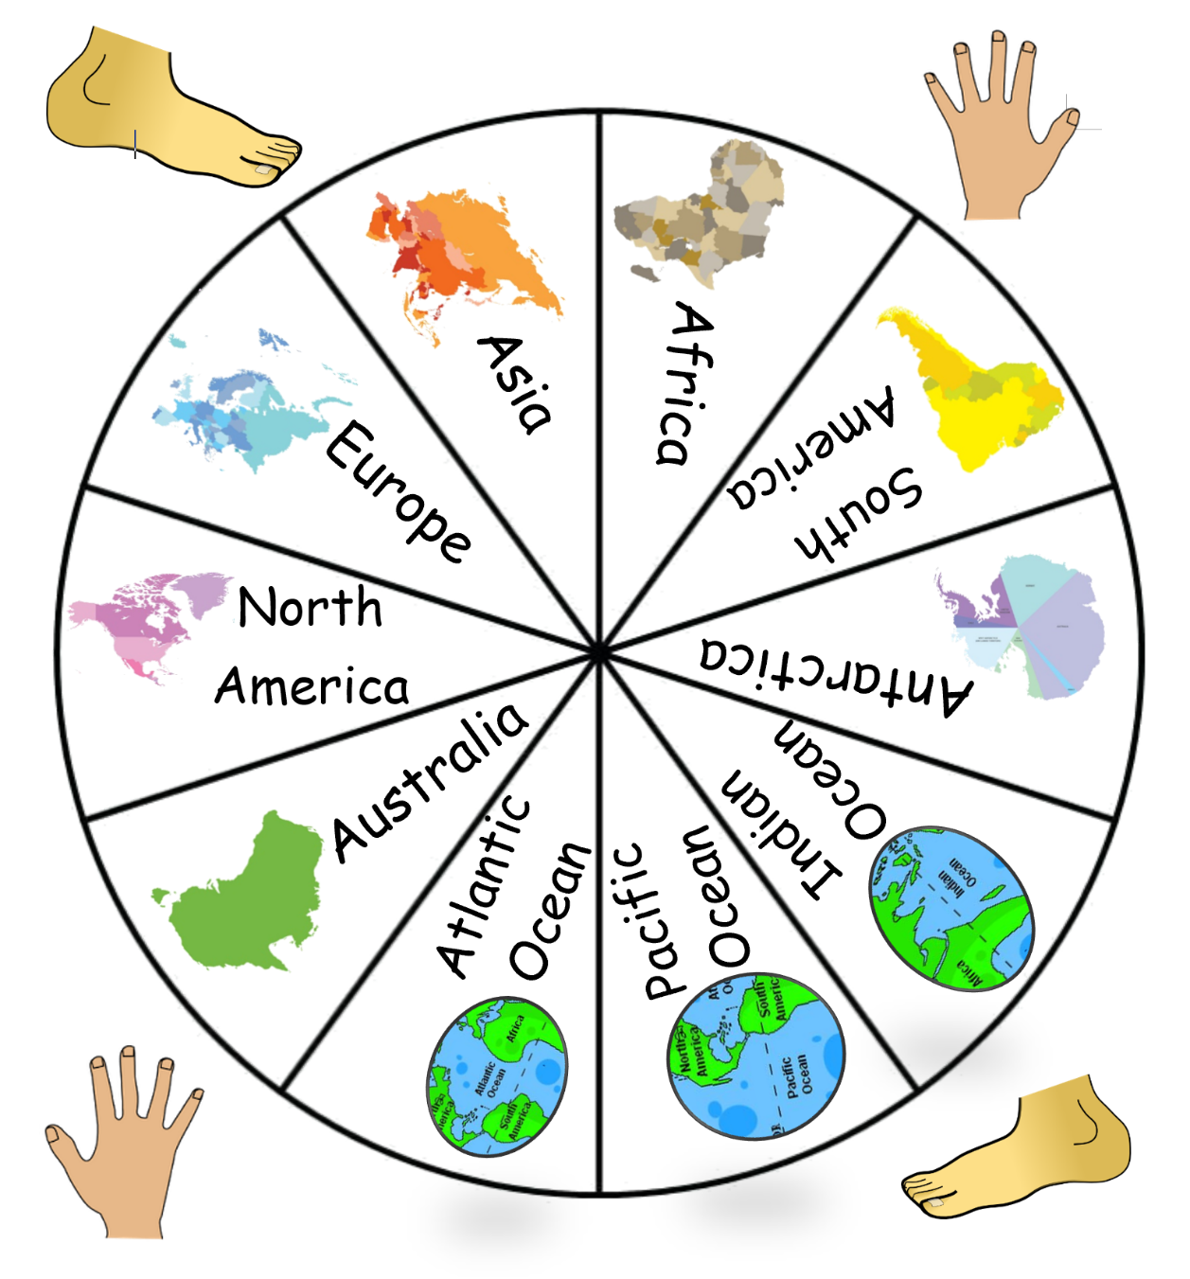

Build a time capsule!

Time Capsule Brainstorm:
- Make a list of possible items to include in our time capsule. Remember they should be fairly small, durable, and representative of this time period.
- After the brainstorm, each participant will choose one or two items to include.

Guiding questions: When do you want people to find this time capsule? Who would you like to find this time capsule?

Item | Significance | Name (If chosen)
Fabric scrap from sewing a mask, might include a label in a bag | Making masks is important at this time but has never been important to me before. I don’t want to include a mask because we need them! | Kate

Create a time capsule!

- Write a letter to include with your thoughts and feelings about this time. What do you want people in the future to know about this time?

- Support your learners:
    - Write a letter together
    - Provide a word bank from words you’ve brainstormed together
    - Provide a model letter
    - Provide a script to follow

- Speak: explain your items for inclusion

- Support your learners:
    - Provide sentence frames
    - I included _____ because______.
    - _____ represents this time to me because ________.
    - ____is important to me because ____.
    - In the future, I want people to know ____ about this time.

- Provide labels or names for items

- Decide where you will “bury” your time capsule
    - Outdoors with a marker
    - Inside in a tucked away place like a closet or a storage space

- Use an appropriate container
    - Metal or glass are best for outside
    - A sturdy box could work for inside

- Reflect on experience with a multi-media presentation:
    - Flipgrid video
    - Google slide presentation

For more questions ideas, visit StoryCorps: https://storycorpsorg-staging.s3.amazonaws.com/uploads/great-questions.pdf
© 1959 - Hasbro

